

Student Name: M.W.V.D.M.J. Wijewickrama
Student Number: 2642837
Module Code: 6CS007
Module Name: Project and Professionalism
Project Title: An AI-Assisted Chest X-ray Training Companion for Student Radiologists Using MedGemma and Retrieval-Augmented Generation
Module Leader Name: Mr. Dhishan Dhammearatchi
Supervisor Name: Mr. Harindu Mansaka
Reader Name: Ms. Shanika Ekanayake
Submission Date: 2026/09/20
Award Title: BSc (Hons) Computer Science in Software Engineering (TopUp)

Declaration

Presented in partial fulfillment of the assessment requirements for the above award. This work or any part thereof has not previously been presented in any form to the University or to any other institutional body whether for assessment or for other purposes. Save for any express acknowledgments, references and/or bibliographies cited in the work, I confirm that the intellectual contents of the work are the result of my own efforts and of no other person.
It is acknowledged that the author of any project work shall own the copyright. However, by submitting such copyright work for assessment, the author grants to the University a perpetual royalty-free licence to do all or any of those things referred to in section 16(i) of the Copyright Designs and Patents Act 1988. (viz: to copy work; to issue copies to the public; to perform or show or play the work in public; to broadcast the work or to make an adaptation of the work).
Student Name (Print): M.W.V.D.M.J. Wijewickrama
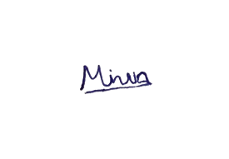
Student Number: 2642837
Signature of the Student: ......................................................
Date: ..............2026/09/20........................................

Abstract

Chest X-ray (CXR) interpretation is a core radiology skill that students develop through repeated case exposure and structured feedback, which is hard to provide at scale in settings affected by a shortage of radiologists. This project designed, built and evaluated a student-in-the-loop CXR training companion that combines MedGemma, a medical vision-language model, with Retrieval-Augmented Generation (RAG) to give evidence-grounded educational feedback on six common findings: pneumothorax, pleural effusion, cardiomegaly, consolidation, nodule or mass, and a no-finding category. The student writes their own interpretation first; teaching passages are then retrieved from a curated corpus and supplied to the model before it generates, and the model marks the student's reading against the case's confirmed finding, returning a structured note covering the key radiographic signs, the missed clues, the supporting evidence and a learning point. The artefact is a FastAPI backend and a React single-page application organised in a Clean Architecture, so that the model, the retriever and the dataset are each swappable behind a narrow interface. Two rounds of evaluation were run against a 300-case balanced subset of the NIH ChestX-ray8 corpus. The first found that MedGemma could not identify the finding from the image at better than close to chance, scoring 16.7 to 23.3 per cent across six prompt strategies against a 14.3 per cent floor, which forced the system's role from diagnosis to marking. The second compared five retrieval arms over 30 samples each within a single session: supplying passages cut the rate at which the model asserted findings that nothing supports from about 61 per cent to between 20 and 27 per cent, at a precision at three of 52 per cent, although the model never once cited a passage it was given. The working prototype and its open evaluation harness provide a baseline against which fine-tuned configurations can be compared in future work.
Keywords: Chest X-ray; Radiology education; MedGemma; Retrieval-Augmented Generation; Vision-language models; Formative feedback.

ACKNOWLEDGEMENT

I would like to thank my supervisor, Mr. Harindu Mansaka, for his guidance, feedback and patience throughout this project. His insight into both the technical and the educational sides of the work helped to shape the artefact and the evaluation plan.
Table of Contents
CHAPTER 1. INTRODUCTION 1
1.1 Chapter Overview 1
1.2 Problem Background 1
1.3 Problem Statement 1
1.4 Aim of the Project 2
1.5 Academic Questions 2
1.6 Research Objectives 3
1.7 Scope of the Project 4
1.7.1 In-Scope 4
1.7.2 Out-of-Scope 4
1.8 Structure of the Proposal 4
CHAPTER 2. LITERATURE REVIEW 6
2.1 Chapter Overview 6
2.2 Literature Review 6
2.2.1 Review of Existing Systems / Similar Works 6
2.2.2 Review of Related Concepts and Theories 9
2.2.3 Technological Review 10
2.3 Research Gap Identification and Justification 11
2.4 Chapter Summary 13
CHAPTER 3. METHODOLOGY 14
3.1 Chapter Overview 14
3.2 Planning 14
3.2.1 Identifying Business Values 14
3.2.2 Feasibility Analysis 15
3.3 Requirement Gathering and Analysis 17
3.3.1 Requirement Gathering 17
3.3.2 Functional Requirements 17
3.3.3 Non-Functional Requirements 18
3.3.4 Use Case Diagram 19
3.3.5 Use Case Narrative 19
3.3.6 Requirements Traceability 24
3.4 System Development Methodology 26
3.4.1 System Design 26
3.4.2 Testing Approach 26
3.4.3 Evaluation Plan 28
3.5 Resource Requirements 28
3.5.1 Tools and Technologies 28
3.6 Project Management Methodology 28
3.6.1 Schedule 28
3.6.2 Risk and Mitigation 30
3.7 Chapter Summary 30
CHAPTER 4. DESIGN 31
4.1 Chapter Overview 31
4.2 System Architecture Diagram 31
4.2.1 Architectural Diagram 31
4.3 Detailed Design 32
4.3.1 Component Diagram 32
4.3.2 Sequence Diagram 34
4.3.3 Activity Diagram 35
4.3.4 Physical Design and Data Flow 35
4.3.5 Deployment Diagram 37
4.3.6 Interface Design 37
4.4 Algorithm Design 38
4.5 Chapter Summary 39
CHAPTER 5. IMPLEMENTATION 40
5.1 Chapter Overview 40
5.2 Technology Selection 40
5.2.1 Technology Stack 40
5.2.2 Programming Languages 40
5.2.3 Development Framework 41
5.2.4 Libraries and Toolkits 41
5.2.5 Integrated Development Environments (IDEs) 42
5.2.6 Summary of Technology Selection 43
5.3 Implementation of the Artefact 43
5.3.1 Implementation of functional requirements 43
5.3.2 Implementation of non-functional requirements 48
5.3.3 Algorithm Implementation 50
5.4 User Interface Implementation 53
5.5 Chapter Summary 54
CHAPTER 6. TESTING 56
6.1 Chapter Overview 56
6.2 Objectives and Goals of Testing 56
6.3 Testing Criteria 56
6.4 Model / System Testing 56
6.4.1 Evaluation Metrics 56
6.4.2 Retrieval and Feedback Evaluation 57
6.4.3 Retrieval Relevance Agreement 57
6.5 Functional Testing 57
6.6 Module and Integration Testing 57
6.6.1 Accuracy / Performance Comparison 57
6.7 Non-Functional Testing 58
6.8 Chapter Summary 58
CHAPTER 7. CONCLUSION 59
7.1 Chapter Overview 59
7.2 Achievements of Research Aims & Objectives 59
7.2.1 Achievement of the Research Aim 59
7.2.2 Achievement of Objectives 59
7.3 Problems and Challenges Faced 60
7.4 Limitations of the Research 61
7.4.1 Deviations [If Any] 62
7.5 Future Enhancements 63
7.6 Concluding Remarks 64
References 65
Appendices 68
Appendix B — Technical Configuration Summary 68
B.1 Model and inference configuration 68
B.2 Prompt configuration 68
B.3 Retrieval configuration 69
B.4 Corpus configuration 69
B.5 Data set configuration 70
B.6 Application configuration 70

List of Tables
Table 1.1: Mapping of academic questions to project objectives 4
Table 2.1: Summary of reviewed systems and their limitations for educational use 12
Table 3.1: Stakeholders and their interest in the artefact 15
Table 3.2: Technical feasibility assessment 15
Table 3.3: Financial feasibility assessment 16
Table 3.4: Operational feasibility assessment 16
Table 3.5: Legal feasibility assessment 16
Table 3.6: Schedule feasibility assessment 17
Table 3.7: Functional requirements 18
Table 3.8: Non-functional requirements 18
Table 3.8a: Use case narratives for UC01 to UC06 20
Table 3.9: Mapping of requirements to design decisions 26
Table 3.10: Mapping of test layers to test scope and tools 27
Table 3.11: Summary of automated test counts 28
Table 3.12: Work breakdown structure of the project 30
Table 4.1: Backend folder structure (Clean Architecture) 32
Table 4.2: Frontend route structure 37
Table 5.1: Backend runtime dependencies and their role
Table 5.2: Frontend dependencies and their role
Table 5.3: Summary of technology selection and justification
Table 5.4: The four retrieval strategies implemented behind the IRetriever port
Table 5.5: Implementation of the non-functional requirements
Table 7.1: Achievement of the research objectives
Table B.1: MedGemma model and inference configuration
Table B.2: Prompt configuration and token budget
Table B.3: Retrieval and ranking configuration
Table B.4: Retrieval corpus configuration
Table B.5: Data set and evaluation sampling configuration
Table B.6: Application and security configuration
List of Figures
Figure 1.1: Structure of the report (chapter flow diagram) 5
Figure 2.1: Overview of the reviewed CXR AI landscape: model, retriever, dataset and evaluation threads 12
Figure 3.1: Use case diagram of the proposed training companion 19
Figure 3.2: Gantt chart of the project plan 29
Figure 4.1: High-level system architecture (Clean Architecture and hexagonal ports) 31
Figure 4.2: Component diagram of the artefact 33
Figure 4.2a: Sequence diagram for student attempt and AI feedback generation 34
Figure 4.2b: Activity diagram for the student-to-feedback workflow 35
Figure 4.3: Context-level Data Flow Diagram (Level 0) 36
Figure 4.4: Level-1 Data Flow Diagram: sub-processes of the system 36
Figure 4.5: Deployment diagram 37
Figure 4.6: Student workflow screen flow (login, case list, case and feedback) 38
Figure 4.7: Educator workflow screen flow (login, review queue and review form) 38
Figure 5.1: Case list showing curated cases with thumbnails and demographics
Figure 5.2: Case page with the radiograph viewer and the free-text attempt form
Figure 5.3: Attempt form with inline validation of the free-text answer
Figure 5.4: Structured feedback note returned after submission
Figure 5.5: Evidence panel showing retrieved teaching passages
Figure 5.6: Educator review queue
Figure 5.7: Educator rubric form, scoring the six criteria the domain accepts
List of Abbreviations
Acronym | Meaning
AI | Artificial Intelligence
API | Application Programming Interface
CORS | Cross-Origin Resource Sharing
CXR | Chest X-ray
DFD | Data Flow Diagram
ERD | Entity-Relationship Diagram
FE | Front End
GDPR | General Data Protection Regulation
GPU | Graphics Processing Unit
HTTP / HTTPS | Hypertext Transfer Protocol (Secure)
IDE | Integrated Development Environment
JSON | JavaScript Object Notation
JWT | JSON Web Token
LLM | Large Language Model
MIMIC-CXR | Medical Information Mart for Intensive Care - Chest X-ray
MVP | Minimum Viable Product
NIH | National Institutes of Health
NIHCC | NIH Clinical Center Chest X-ray dataset
NIST | National Institute of Standards and Technology
NLP | Natural Language Processing
ORM | Object-Relational Mapper
OWASP | Open Worldwide Application Security Project
PACS | Picture Archiving and Communication System
PDPA | Personal Data Protection Act (Sri Lanka)
PEFT | Parameter-Efficient Fine-Tuning
QA | Quality Assurance
RAG | Retrieval-Augmented Generation
RBAC | Role-Based Access Control
REST | Representational State Transfer
SPA | Single-Page Application
SQL | Structured Query Language
UI / UX | User Interface / User Experience
URL | Uniform Resource Locator
VLM | Vision-Language Model
VQA | Visual Question Answering
WBS | Work Breakdown Structure
WHO | World Health Organization
ASGI | Asynchronous Server Gateway Interface
BM25 | Best Matching 25 (Okapi ranking function)
CSV | Comma-Separated Values
CTR | Cardiothoracic Ratio
IDF | Inverse Document Frequency
LoRA | Low-Rank Adaptation
SHA-256 | Secure Hash Algorithm, 256-bit
TTL | Time To Live
YAML | YAML Ain't Markup Language
List of Equations
Three formal equations are used in this report. Equation 4.1 in Chapter 4 (Design) is the cardiothoracic ratio used in the cardiomegaly prompt template. Equations 5.1 and 5.2 in Chapter 5 (Implementation) are the smoothed inverse document frequency and the saturating score normalisation used by the retrieval layer. They are listed here for completeness.
Equation | Title | Page
Equation 4.1 | Cardiothoracic ratio (CTR) used in the cardiomegaly prompt template | 38
Equation 5.1 | Smoothed inverse document frequency used by the BM25 ranker
Equation 5.2 | Saturating normalisation of the raw BM25 score

INTRODUCTION

Chapter Overview
This chapter introduces the project: the problem background, the specific problem, the aim, the academic questions, the objectives, the scope and the structure of the report.

Problem Background
Medical imaging is central to modern hospital care, and the chest X-ray (CXR) is one of the most frequently performed radiological examinations worldwide. Interpreting a CXR is a foundational skill for radiologists, but it develops slowly through repeated exposure to varied cases and through structured feedback from supervisors. Training therefore depends on expert time and on access to good teaching cases (World Health Organization, 2021; Karunaratne, 2023).
At the same time, artificial intelligence has advanced quickly in medical imaging. Medical vision-language models such as MedGemma can describe a radiograph in natural language, and Retrieval-Augmented Generation can tie what such a model says to a named source rather than leaving it to the model's recollection. Most of this work is aimed at assisting clinicians with diagnosis. Far less of it asks what these systems could do for a student who is still learning to read the film, where being told the answer is precisely the wrong help.

Problem Statement
The training-pipeline problem is especially acute in low- and middle-income settings. Sri Lanka, for example, has only around 0.78 radiologists per 100,000 population, compared with approximately 13 per 100,000 in Europe and 8.5 per 100,000 in the United Kingdom (Karunaratne, 2023). The shortage is made worse by the cost of training, by trainees staying abroad after overseas training, by rising demand from an ageing population, and by ageing imaging equipment that constrains hands-on training. Because radiology training takes several years, the shortage cannot be fixed quickly, and the training pipeline itself becomes a bottleneck.
Student radiologists need repeated case exposure and structured feedback, but supervised feedback on every practice case does not scale, and it is scarcest exactly where radiologists are scarcest. That is the gap this project addresses: not a system that reads the film for the student, but one that responds to what the student wrote about it.

Aim of the Project
The aim of this project is to design, implement and evaluate a student-in-the-loop chest X-ray training companion that uses MedGemma and Retrieval-Augmented Generation to provide structured, evidence-grounded educational feedback on a small set of common CXR findings.
The project is guided by these specific aims:
To design an architecture that separates the model, the retriever and the dataset behind narrow interfaces, so each can be replaced without changing the application code.
To implement a working prototype that realises the student-attempt-then-AI-feedback workflow using MedGemma and a pluggable RAG layer over a curated corpus.
To set up a reproducible evaluation harness that measures technical performance (structure validity, finding recognition, latency, token usage) as well as educational quality (clarity, evidence grounding, usefulness for learning).
To position the system as a formative learning aid, not as a clinical decision-support or diagnostic tool, and to document the ethical, legal and security considerations that follow from that positioning.

Academic Questions
The project is framed by one main academic question and four sub-questions. They follow directly from the problem statement and the aims and define what the evaluation must be able to answer.
Main academic question: How can a medical vision-language model and Retrieval-Augmented Generation be combined to provide reliable, evidence-grounded feedback that supports student radiologists in practising chest X-ray interpretation?
Sub-questions:
AQ1: What limitations do current AI systems for CXR interpretation have when they are used as tools for student learning rather than clinical diagnosis?
AQ2: How can MedGemma be adapted or prompted to support students in practising interpretation of selected chest X-ray findings?
AQ3: Does Retrieval-Augmented Generation improve the grounding, clarity and educational usefulness of the feedback generated for chest X-ray training?
AQ4: Which configuration - MedGemma only, MedGemma + RAG, or fine-tuned MedGemma + RAG - provides the best balance between finding recognition, evidence grounding and feedback quality, when evaluated against a defined rubric?

Research Objectives
The following SMART objectives will collectively achieve the aim and answer the academic questions:
O1: To review existing literature, models and systems related to AI-assisted chest X-ray interpretation and RAG, and to identify their limitations for educational use.
O2: To select a narrow set of common CXR findings and to gather suitable public image data and labels for those findings.
O3: To gather and analyse the functional and non-functional requirements of a student-facing training companion, including the required feedback components.
O4: To design the architecture, data flow and a curated educational RAG corpus for the proposed system.
O5: To implement a working prototype that realises the student-attempt-then-AI-feedback workflow using MedGemma and RAG.
O6: To test and evaluate the prototype against defined success criteria, comparing MedGemma only, MedGemma + RAG and (if time allows) fine-tuned MedGemma + RAG, and to document the process and findings.
Table 1.1 maps the academic questions to the objectives, so the traceability between the research questions and the work is explicit.
Academic question | Objectives that address it | Chapter / Section
AQ1 - limitations of existing CXR AI systems for educational use | O1, O3 | Chapter 2 (Sections 2.1, 2.2)
AQ2 - adapting MedGemma for student-facing interpretation | O4, O5 | Chapter 3 (Sections 3.3, 3.4)
AQ3 - whether RAG improves grounding, clarity and learning usefulness | O4, O5, O6 | Chapter 3 (Sections 3.4, 3.5)
AQ4 - best configuration across MedGemma only, MedGemma + RAG, and fine-tuned MedGemma + RAG | O5, O6 | Chapters 3 and 4
Main AQ - combining a medical VLM and RAG for student-facing CXR training | O1 - O6 | Chapters 1-4
Table 1.1: Mapping of academic questions to project objectives

Scope of the Project
The scope of the work is described in two parts: what is in scope and what is out of scope.

In-Scope
Selected findings: a small set of common chest X-ray findings suitable for student training. The candidate set is pneumothorax, pleural effusion, cardiomegaly, consolidation / airspace opacity, nodule or mass, and a no-finding category. The final subset is fixed by dataset label quality and availability.
Core workflow: the student-in-the-loop workflow in which a learner first records their own interpretation, then receives MedGemma-based image analysis and RAG-retrieved evidence, and finally an educational feedback note.
Platform: a prototype web application accessible via desktop browsers, using de-identified public CXR images only.
Evaluation: a comparative evaluation of MedGemma only against MedGemma + RAG (and fine-tuned MedGemma + RAG if time allows), covering both technical performance and educational feedback quality.

Out-of-Scope
Clinical diagnosis, treatment or patient-management decisions - excluded because the system is an educational tool, and clinical deployment is beyond the project's academic scope.
Use of real, identifiable patient data or live hospital images - excluded due to data-protection, ethical-approval and licensing constraints.
Coverage of all thoracic diseases or all CXR abnormalities - excluded to keep the corpus, evaluation and timeline feasible for a final-year project.
A native mobile application - excluded due to time constraints; the prototype targets desktop browsers only.
Integration with hospital information systems or PACS - excluded as outside the educational scope and not available within the project constraints.

Structure of the Proposal
The rest of this report is organised as follows. Chapter 2 reviews related work and identifies the gap. Chapter 3 sets out the methodology, the requirements and the project plan. Chapter 4 presents the design. Chapter 5 describes the implementation. Chapter 6 reports the testing and evaluation. Chapter 7 assesses the work against its objectives and sets out the limitations and future directions. Figure 1.1 shows the chapter flow and how each chapter traces back to the academic questions in Section 1.5.
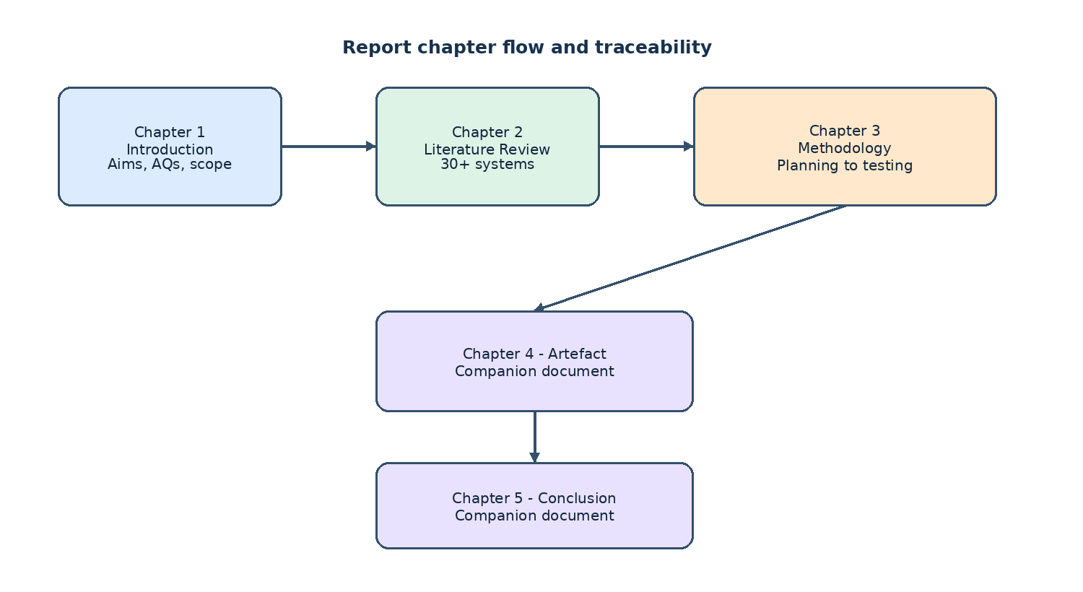
Figure 1.1: Structure of the report (chapter flow diagram)

LITERATURE REVIEW

Chapter Overview
This chapter reviews existing academic work, models and systems relevant to AI-assisted chest X-ray interpretation and to Retrieval-Augmented Generation in healthcare. The purpose is to position the proposed training companion against what already exists, to identify the strengths and limitations of current approaches, and to set up the gap that this project addresses. The review draws on recent peer-reviewed articles, technical reports and preprints on medical vision-language models, RAG for bio medicine, and chest X-ray interpretation systems, supplemented by the public CXR datasets, the standard benchmarks and the existing e-learning platforms that the artefact has to interoperate with.
Section 2.2 reviews the existing systems and similar work. It is organized in seven thematic groups - CXR-specific vision-language models, general medical / biomedical VLMs, agentic and multi-agent systems, RAG frameworks, the public CXR datasets, the CXR benchmarks, and the existing e-learning platforms - and ends with a summary of the research gap and how the findings shape the artefact design.

Literature Review
This section reviews the systems, datasets, benchmarks and e-learning platforms most relevant to the proposed training companion. The review is deliberately broad - more than 30 systems and resources are discussed - so that the gap addressed by the project is positioned against the full landscape rather than a single thread.

Review of Existing Systems / Similar Works

CXR-Specific Vision-Language Models
CXR-LLaVA (Lee et al., 2025).
A multimodal LLM fine-tuned for chest X-ray interpretation that adapts a general vision-language assistant to radiology images and links them to explanatory text. Evaluation focuses on report-generation metrics (BLEU, CIDEr). It is designed for clinical reporting, not for student learning, and does not ground its explanations in retrievable teaching evidence.
CheXagent (Chen et al., 2024).
A foundation model for chest X-ray interpretation, trained on a large corpus of CXR-report pairs and bench-marked against several standard CXR tasks. It is diagnostic in orientation and produces a report-style output rather than a structured learning note keyed to a student's attempt.
MedGemma (Sellergren et al., 2025).
A medical vision-language model released by Google Health AI Developer Foundations with competitive performance on a range of medical image and text tasks at a model size that runs on a single accelerator. It is a foundation model whose baseline behaviour is general, and adapting it to an educational workflow needs deliberate prompting, retrieval support and a clear feedback schema.
LLaVA-Med (Li et al., 2023).
Extends a general-purpose assistant to the biomedical domain efficiently through a one-day instruction-tuning process over a curated biomedical instruction dataset. It is broad rather than specialized for CXR education, and the output is free-form question answering rather than structured educational feedback.
LLaVA-Rad (Zambrano Chaves et al., 2025).
A small multi-modal radiology model with a clinically grounded evaluation metric, showing that small VLMs can be competitive on standard CXR tasks when paired with task-specific evaluation. It focuses on clinical grounding, not on educational feedback design.

General Medical and Biomedical VLMs and Adjacent Models
LLaVA-Med as a general biomedical multimodal assistant (Li et al., 2023).
A one-day instruction-tuning process over a curated biomedical instruction datasets adapts a general-purpose assistant to the biomedical domain. The multi-modal coverage is wider than a single CXR student companion needs, and the output is free-form question answering rather than structured educational feedback.
MedGemma as a multimodal medical VLM (Sellergren et al., 2025).
A medical vision-language model released by Google Health AI Developer Foundations. It is intended as a foundation model; adapting it to a particular educational workflow needs deliberate prompting, retrieval support and a clear feedback schema.
Explainable foundation models for medical diagnosis (Lin et al., 2025).
A foundation model with human-compatible reasoning via reinforcement learning, with clinical explainability as an explicit design goal. Clinical explainability is a useful direction but the model is large and the training setup is not feasible in a free-tier notebook.

Agentic and Multi-Agent CXR / Imaging Systems
CXRAgent (Lou et al., 2025).
A director-orchestrated multi-stage reasoning system for chest X-ray interpretation that coordinates a director model with several specialist stages to produce a structured CXR report. The orchestration complexity is hard to justify in an undergraduate prototype and the system is not framed for student feedback.
MedRAX.
An agentic CXR analysis system that uses tools to perform retrieval, classification and grounding in a single workflow. It is a tool-use architecture aimed at clinical decision support, not learning-oriented, and the runtime cost is high.
Multi-agent RAG for clinical decision support (Mugambiwa and Ndlovu, 2026).
A systematic review and integrative framework for multi-agent RAG systems in clinical decision support. Useful as conceptual background but does not by itself provide a student-facing feedback loop.
ACR Appropriateness multi-agent RAG (Pambudi and Menolascina, 2025).
A multi-agent RAG system that bridges clinical narratives and ACR Appropriateness Guidelines to support medical imaging decisions. It is clinical-decision-support focused, and the retrieval is over clinical appropriateness criteria rather than teaching material.
LLM for DRG and clinical decision support (Papageorgiou et al., 2025).
A study of the role of large language models in improving diagnostic-related groups (DRG) assignment and clinical decision support in radiology and nuclear medicine. It shows the breadth of clinical AI but is operational / administrative and does not address student feedback.

Existing Radiology E-Learning Platforms
Radiopaedia.
A free online radiology encyclopedia with thousands of cases, served as articles with embedded images and curated differential diagnoses. Excellent for browsing but is a static reference rather than a feedback loop; there is no student-attempt workflow.
Radiology Masterclass.
A subscription-based radiology e-learning platform with courses and case libraries aimed at trainees preparing for the FRCR. Course-based; provides good teaching material but not an AI-assisted feedback loop.
RadiologyAssistant.
A free, peer-reviewed radiology teaching site organised by body region, with structured articles and image galleries. Reference material rather than an interactive trainer; the workflow is read-then-look.
Statdx and RADPrimer.
Commercial diagnostic decision-support and e-learning platforms used by radiology trainees worldwide. They pair cases with structured differential diagnoses and curated image libraries, but they are commercial and closed with no student-facing API, so they cannot be integrated into a free-tier prototype.
Khanmigo and AI tutors in general education.
AI tutors used in K-12 and higher education, including Khan Academy's Khanmigo, that show the pattern of student-first-then-feedback tutoring. Domain-agnostic; they do not reason over medical images, so they are useful as a UX reference rather than a content reference.
PathXL and virtual-slide platforms.
Virtual-slide e-learning platforms for pathology and histology training that pair whole-slide images with structured teaching material and assessment. Pathology-focused rather than CXR, but useful as a UX reference for image-centric training tools.
OSCE and case-based assessment platforms.
Assessment platforms used by medical schools for OSCE-style station practice that pair clinical vignettes with structured answer schemes and examiner scoring. Focused on assessment rather than on per-case feedback; the structured answer schemes are a useful pattern to imitate.

Review of Related Concepts and Theories

RAG Frameworks in Healthcare and Biomedicine
Abo El-Enen, Saad and Nazmy (2025) - RAG in healthcare survey.
A survey of RAG models for healthcare applications covering architectures, datasets, evaluation and open challenges. It identifies retrieval quality and corpus curation as decisive factors but does not provide a CXR-specific implementation.
Amugongo et al. (2025) - RAG systematic review for LLMs in healthcare.
A PLOS Digital Health systematic review of retrieval-augmented generation for LLMs in healthcare, summarising evidence on grounding and reduced hallucination. The evidence base is still thin on education-specific outcomes.
Liu, McCoy and Wright (2025) - RAG in biomedicine.
A JAMIA systematic review, meta-analysis and clinical development guidelines for RAG in biomedical LLM applications, with practical guidance for clinical development. The 'clinical development guidelines' emphasis assumes deployment in a regulated environment, which is out of scope here.
Collaco et al. (2026) - fine-tuning and RAG scoping review.
A Bioengineering scoping review of how PEFT / fine-tuning and RAG can be integrated in healthcare AI systems. Useful to position the future fine-tuning step of this project.
Lin et al. (2025) - explainable foundation model for medical diagnosis.
A foundation model with human-compatible reasoning via reinforcement learning. Clinical explainability is a useful direction but the model is large and the training setup is not feasible in a free-tier notebook.

CXR Benchmarks and Evaluation Frameworks
ReXVQA (Pal et al., 2025).
A large-scale visual-question-answering benchmark for generalist chest X-ray understanding. It is a benchmark, not a training system, and the QA-style evaluation does not measure the educational quality of free-text feedback.
Pathology localisation benchmark (Gosai et al., 2025).
An evaluation of multimodal LLMs for pathology localisation in chest radiographs, moving beyond naming a disease towards identifying the abnormal region. A localisation metric only; does not capture whether the model's explanation helps a learner understand their reasoning error.
Additional CXR benchmarks (CheXlocalize, RadImageNet, RadGraph, MS-CXR).
A weakly-supervised CXR localisation benchmark (CheXlocalize), a large pre-trained radiology model and dataset (RadImageNet), a graph representation of radiology report entities and relations (RadGraph), and a paired image-text dataset with sentence-level phrase grounding (MS-CXR). Each addresses one slice of the evaluation surface but none measures the educational quality of free-text feedback in the way the rubric in Section 3.3 does.

Technological Review

Public CXR Datasets
NIH ChestX-ray8 (Wang et al., 2017).
112,120 frontal-view CXR images from 30,805 unique patients, with 14 pathology labels mined from associated radiology reports by an NLP pipeline. The de-facto Phase 1 corpus for this project; labels are noisy, with multi-label accuracy against radiologist adjudication in the 70-90% range depending on the label.
MIMIC-CXR (Johnson et al., 2019).
A large de-identified database of chest radiographs paired with free-text reports. The Phase 1.5 fallback; requires PhysioNet credentialing, and reports are richer but not designed for educational use.
MIMIC-CXR-JPG.
A JPG-derivative of MIMIC-CXR with pre-extracted image metadata, released to make the corpus easier to consume at scale. Same credentialing requirements as MIMIC-CXR; considered for Phase 1.5.
Additional large CXR corpora (CheXpert, Padchest, VinDr-CXR).
CheXpert adds uncertainty labels for 14 observations; Padchest is a large Spanish CXR dataset with structured labels and free-text reports; VinDr-CXR provides bounding-box labels for 28 findings. Each is larger or more specialised than NIH ChestX-ray8 but has label structures that are not the focus of Phase 1; all are candidates for the Phase 1.5 corpus swap.
Specialised CXR corpora (RSNA Pneumonia, Open-i, TBX11k, SIIM-ACR PTX).
A radiologist-labelled subset of NIH ChestX-ray8 used for the 2018 RSNA challenge (RSNA Pneumonia); an open-access corpus of around 7,000 CXR images from the Indiana University hospital network (Open-i); a tuberculosis-specific dataset of around 11,000 images (TBX11k); and a pneumothorax-specific subset of NIH ChestX-ray8 with segmentation masks from the 2019 SIIM-ACR challenge. Each is single-finding or otherwise narrowly scoped, so they are useful as additional evaluation material or for follow-up work but not as the primary training source for a multi-finding training companion.

Research Gap Identification and Justification
Across the seven groups above, four connected gaps emerge. Methodologically, there are limited comparisons between prompting-only, RAG-based and fine-tuned + RAG approaches for educational chest X-ray training. Empirically, few studies evaluate image-interpretation quality and evidence-grounded feedback quality together, especially in a student learning context. From a knowledge perspective, there is no clear best practice for combining a medical VLM with RAG to build a reliable, useful CXR training companion for students. And educationally, the existing AI radiology systems are framed around clinical support, diagnosis or report generation, not around student practice.
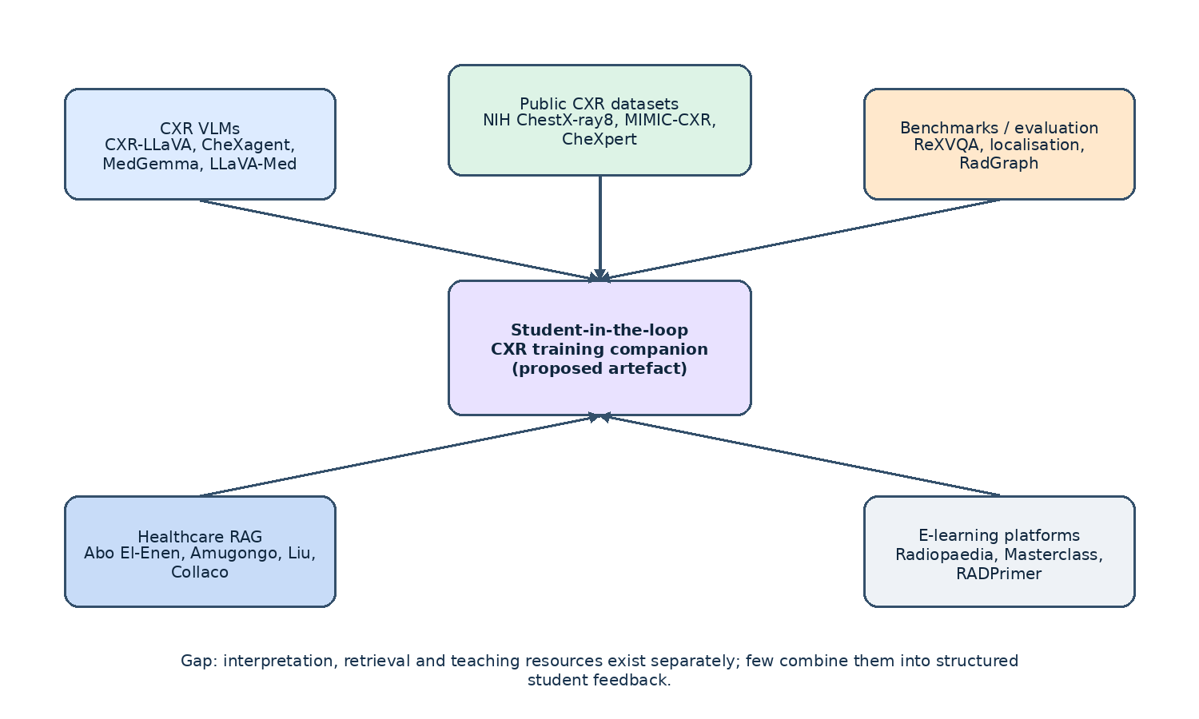
Figure 2.1: Overview of the reviewed CXR AI landscape: model, retriever, dataset and evaluation threads
Group | Systems discussed | Key limitation for educational use
CXR-specific VLMs | CXR-LLaVA, CheXagent, MedGemma, LLaVA-Med, LLaVA-Rad | Clinical reporting orientation; no formative feedback design
General biomedical VLMs and adjacent models | LLaVA-Med (broader use), MedGemma, Lin et al. | Foundation models; need prompting and a feedback schema
Agentic and multi-agent systems | CXRAgent, MedRAX, multi-agent RAG surveys, ACR-appropriateness RAG, DRG-LLM | Clinical-decision focus; orchestration complexity not justified for a student prototype
RAG frameworks in healthcare | Abo El-Enen, Amugongo, Liu et al., Collaco et al., Lin et al. | Clinical deployment focus; little CXR-education evidence
Public CXR datasets | NIH ChestX-ray8, MIMIC-CXR, MIMIC-CXR-JPG, CheXpert, Padchest, VinDr-CXR, RSNA Pneumonia, Open-i, TBX11k, SIIM-ACR PTX | Noisy NLP-mined labels; not designed for educational use
CXR benchmarks and evaluation | ReXVQA, pathology localisation, CheXlocalize, RadImageNet, RadGraph, MS-CXR | Technical metrics; do not measure educational quality
Existing e-learning platforms | Radiopaedia, Radiology Masterclass, RadiologyAssistant, Statdx, RADPrimer, Khanmigo, PathXL, OSCE platforms | Read-then-look or assessment workflow; no AI feedback loop
Table 2.1: Summary of reviewed systems and their limitations for educational use

Chapter Summary
These four gaps link directly back to the problem statement in Section 1.3 and the main academic question in Section 1.5, and they shape the methodology described in Chapter 3.

METHODOLOGY

Chapter Overview
This chapter describes the methodology used to develop the artefact. It begins with the planning phase, which covers stakeholder identification, a structured feasibility analysis across the five canonical feasibility dimensions, and the work plan. It then describes the analysis and requirement-gathering phase, the design phase (physical, architectural and interface), the implementation phase, and the testing phase.

Planning
The planning phase establishes why and how the project is built. It begins with the identification of the stakeholders and the business values that the artefact must serve, then presents a structured feasibility analysis across the five canonical feasibility dimensions, and ends with a work breakdown structure and a Gantt chart that define the schedule.

Identifying Business Values
The 'business' for this project is the radiology training pipeline. The artefact is a student-facing training tool, not a commercial product, so the term 'business values' is read as the set of stakeholder interests that justify the investment of time and compute. Table 3.1 lists the stakeholders and their interest in the artefact.
Stakeholder | Interest in the artefact | Value delivered
Student radiologist (primary user) | Repeated, structured practice on common CXR findings with evidence-grounded feedback | A safe environment in which the learner can attempt a case, compare their interpretation with an AI-assisted reference, and see retrieved teaching material
Radiology educator / supervisor | A controlled baseline of formative support for common findings | An assessment tool and a structured review queue that reduces the time spent on repetitive first-pass feedback
Module leader and reader | Evidence that the chosen methodology is sound, the project is feasible, and the evaluation is rigorous | A clearly written methodology chapter, a reproducible evaluation harness, and an interpretable report
Project supervisor (Mr. Harindu Mansaka) | Visibility into progress, evidence of academic rigour, and an artefact that can be used as a discussion base in supervision meetings | Iterative demos, a tracked test suite, and a documented decision log
Healthcare system (indirect) | A training pipeline that contributes to a larger future workforce | A defensible, scope-limited prototype that does not make diagnostic claims
Future patients of today's students (indirect) | Better-trained radiologists making fewer interpretation errors | A pipeline that is designed to be safe, transparent and auditable
Table 3.1: Stakeholders and their interest in the artefact

Feasibility Analysis
A feasibility study was carried out along the five canonical feasibility dimensions. The analysis is documented in Tables 3.2 to 3.6 and is summarized below.

Technical Feasibility
Dimension | Assessment
Compute for MedGemma inference | Free Kaggle notebook (T4 / P100, 30 GPU hours / week) is sufficient for the 4-bit quantised 1.5-4B-IT variant. Inference is wrapped in a small Flask app exposed via ngrok; the project's FastAPI backend calls it through the IMedGemmaClient port.
Compute for development | Local Python 3.11+ and Node 22+ environments are sufficient. The backend runs on a developer workstation without a GPU by switching to the deterministic dry-run analyzer.
Model access | MedGemma is gated on Hugging Face. Access was applied for at the start of the project; the dry-run analyzer keeps the rest of the system testable while access is being processed.
Data availability | NIH ChestX-ray8 is fully public. The selected subset of around 5,000 images with the Data_Entry_2017_v2020 metadata is available on the developer workstation.
Tooling | FastAPI, SQLAlchemy, Pydantic, React 18, Vite, TanStack Query, Tailwind - all mature, well-documented libraries.
Conclusion | Technically feasible. The only conditional item is the MedGemma access grant; the dry-run path is sufficient for development and the live path is the production switch.
Table 3.2: Technical feasibility assessment

Financial Feasibility
Item | Cost (USD) | Source
Compute for MedGemma inference | 0.00 | Kaggle free tier (30 GPU hours / week)
Public tunnel for the notebook | 0.00 | ngrok free tier
Version control | 0.00 | Git
Editor | 0.00 | VS Code
Dataset | 0.00 | NIH ChestX-ray8 (public, no licensing fee)
Model weights | 0.00 | MedGemma 1.5-4B-IT (research-use license)
Domain and hosting | 0.00 | Local workstation; the project is not deployed publicly in Phase 1
Total cash outlay | 0.00 | -
Conclusion | Financially feasible within an undergraduate project budget. The cash outlay is zero; the cost is in developer time and in Kaggle GPU quota, which is the binding constraint.
Table 3.3: Financial feasibility assessment

Operational Feasibility
Dimension | Assessment
Team | Single developer, with weekly supervision and a module-leader review at each milestone.
Time | About 15 weeks of part-time work, mapped to the 15-week semester. The schedule is detailed in Section 3.6.1.
Tooling fluency | Python, JavaScript / TypeScript, FastAPI, React, SQL and basic ML are within the developer's existing skill set. The Kaggle notebook and ngrok tunnel are new infrastructure components and are scoped as a single setup task.
Supervisor availability | Weekly supervision slots with Mr. Harindu Mansaka. Module leader checkpoints at the proposal, professionalism assessment, 50% development milestone and final submission.
Risk | Kaggle GPU quota and ngrok session lifetime are the main operational risks. Both are mitigated by the dry-run analyzer and by an idempotent rebuild script.
Conclusion | Operationally feasible. The plan fits inside the academic calendar and the developer time envelope.
Table 3.4: Operational feasibility assessment

Legal Feasibility
Dimension | Assessment
Dataset licensing | NIH ChestX-ray8 is released for research and educational use; the licence permits the project's use case (Wang et al., 2017).
Model licensing | MedGemma is released under the Health AI Developer Foundations terms, which permit research use and fine-tuning (Sellergren et al., 2025).
Personal data | Only de-identified public CXR images are used. No patient names, hospital numbers, dates of birth or other identifiers are stored. The Personal Data Protection Act, No. 9 of 2022 of Sri Lanka is respected (Parliament of Sri Lanka, 2022).
Student data | Student interpretations are stored as pseudonymous UUID-keyed records. Participation is voluntary and separated from academic marking.
Educational-use framing | The interface states clearly: 'For educational use only. Not for clinical decision-making, diagnosis, treatment or patient management.' The disclaimer is repeated on every page via a persistent banner.
Intellectual property | The RAG corpus uses only open-access papers and openly licensed guidelines. A source register records every document used.
Conclusion | Legally feasible within the educational and research-use scope of the project.
Table 3.5: Legal feasibility assessment

Schedule Feasibility
Phase | Weeks | Deliverable
1. Literature Review and Proposal | 1-3 | Approved proposal
2. Requirement Analysis and Data Selection | 4-5 | Requirements document; selected findings and data
3. System Design and Corpus Build | 6-7 | Architecture / design documents; curated RAG corpus
4. Implementation - MedGemma baseline | 8-9 | Baseline prototype (MedGemma only)
5. Implementation - RAG layer | 10-11 | MedGemma + RAG prototype
6. Implementation - optional fine-tuning | 12-13 | Fine-tuned + RAG (if feasible)
7. Testing and Evaluation | 14 | Test report; rubric-based feedback evaluation
8. Documentation and Submission | 15 | Final thesis / report
Table 3.6: Schedule feasibility assessment

Requirement Gathering and Analysis

Requirement Gathering
Requirements were elicited from three primary sources. Document analysis covered the Project Proposal, the Literature Review and the Professionalism Assessment. Comparable systems were studied to refine the user-facing workflow and the shape of the feedback. Supervisor review settled the list of findings, the architecture, the feasibility plan and the work breakdown structure. Secondary reading of the standard chest X-ray benchmarks established what these models are ordinarily asked to do, and of the NIH documentation what its labels actually mean.

Functional Requirements
The analysis phase turns the literature review and the project proposal into a concrete set of requirements. Functional requirements describe what the system must do; non-functional requirements describe the qualities the system must have. The use case diagram (Figure 3.1) captures the actors and the major interactions.
ID | Type | Requirement
FR-1 | Functional | Display a chest X-ray image from a curated public dataset to the student.
FR-2 | Functional | Allow the student to record their own interpretation before any AI output is shown.
FR-3 | Functional | Analyse the image with MedGemma to propose likely findings and an initial explanation.
FR-4 | Functional | Retrieve relevant teaching evidence from a curated corpus using RAG.
FR-5 | Functional | Generate a feedback note: likely finding, key signs, comparison with the student's answer, missed clues, supporting evidence, and a learning point.
FR-6 | Functional | Display retrieved source citations alongside the feedback.
FR-7 | Functional | Allow the educator / reviewer to browse a queue of submitted attempts and submit rubric-based reviews.
FR-8 | Functional | Enforce role separation: STUDENT, EDUCATOR, ADMIN.
Table 3.7: Functional requirements

Non-Functional Requirements
ID | Type | Requirement
NFR-1 | Non-functional (Usability) | Feedback must be clear and understandable at the intended student level.
NFR-2 | Non-functional (Reliability) | Separate model-suggested findings from retrieved teaching evidence; state uncertainty where appropriate.
NFR-3 | Non-functional (Security) | Enforce role separation, secure secret handling, input / file validation.
NFR-4 | Non-functional (Traceability) | Log prompt version, model version and retrieved passages for each feedback item to support evaluation.
NFR-5 | Non-functional (Performance) | Return feedback within a reasonable interactive time on available hardware.
NFR-6 | Non-functional (Privacy) | Use only de-identified public CXR data and never log the student's free-text interpretation alongside an identifier.
NFR-7 | Non-functional (Maintainability) | Organise the code so that the model, the retriever and the dataset can be replaced without changing the application code.
Table 3.8: Non-functional requirements

Use Case Diagram
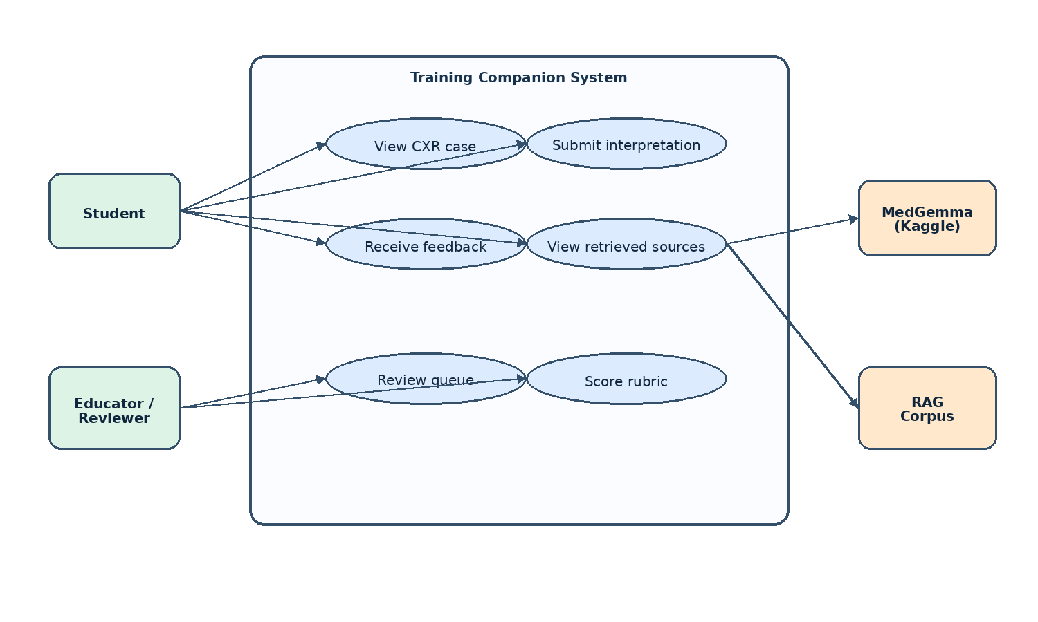
Figure 3.1: Use case diagram of the proposed training companion

Use Case Narrative
The following narratives cover every use case shown in Figure 3.1. Together they define the student workflow from opening a case to inspecting the evidence, and the educator workflow from opening the review queue to submitting a rubric score. Each narrative records its preconditions, trigger, normal flow, exception handling and postconditions.

Use Case Narratives
Use case | Actor | Precondition and trigger | Main flow | Postcondition
UC01 View CXR Case | Student | Authenticated, at least one curated case available. Student selects a case from the list. | The backend verifies access and loads the image and de-identified metadata; the interface shows the radiograph, age, sex and view, enables the interpretation field and keeps all AI output hidden. | The case is visible and ready for an independent interpretation; no model answer has been exposed.
UC02 Submit Interpretation | Student | A case is open and no AI output has been shown. Student completes the field and selects Submit. | The interface validates the interpretation; the backend creates an attempt linked to student and case, stores the original text with the prompt version and time, and passes image and text to feedback generation. | One traceable attempt is stored, ready for analysis, retrieval and feedback.
UC03 Receive Feedback | Student | A valid attempt is stored and the model and retrieval adapters are available. Generation starts on submission. | MedGemma analyses the radiograph; the backend parses finding, confidence and key signs; the retriever returns passages; the generator compares the student's text with the model output and produces the finding, key signs, comparison, missed clues, evidence and a learning point. | The feedback package is stored against the attempt and shown to the student, who becomes available for educator review.
UC04 View Retrieved Sources | Student | Feedback exists with zero or more retrieval records. Student selects Show evidence. | The panel expands and the backend returns the passages stored with the attempt, each with source title, excerpt and relevance; the panel collapses again without leaving the screen. | The student can tell retrieved evidence from model-suggested findings and inspect the grounding used.
UC05 Review Queue | Educator | Authenticated with the educator role; the queue may legitimately be empty. Educator opens the review-queue route. | The backend verifies the role and returns submitted attempts with their review status; the educator browses and selects one, and the system shows the radiograph, student interpretation, feedback and evidence. | The attempt and everything needed for structured review are visible to the educator.
UC06 Score Rubric | Educator | An educator has opened an attempt and can see image, interpretation, feedback and evidence. Educator submits the review form. | The educator assigns 1-5 scores across the six rubric criteria and may add a comment; the interface validates the values, and the backend re-checks the role, saves the review against the attempt and records reviewer metadata. | A traceable review is stored and the attempt is marked reviewed, without altering the student's interpretation or the feedback.
Table 3.8a: Use case narratives for UC01 to UC06
Exception handling is consistent across the six. An unauthenticated request is redirected to login and an unauthorised one is refused. A case that cannot be loaded returns the student to the case list with an error. An empty interpretation is rejected with a validation message, and a duplicate submission returns the existing attempt rather than creating a second. If the model response cannot be parsed the failure is logged and no partial finding is displayed; if retrieval returns nothing, the feedback says so rather than inventing a citation. Missing source metadata is logged and the passage is shown without fabricated bibliographic details. Out-of-range rubric scores are rejected with field-level guidance, and a storage error leaves the review form available for resubmission.

Requirements Traceability
Table 3.9 maps the requirements to the design decisions that realise them. The traceability between requirement and design is what allows the methodology chapter to be checked against the academic questions in Chapter 1.
Requirement | Design decision | Where in the artefact
FR-1 | ManifestRepository reads a CSV of cases; images are served by a FastAPI StaticFiles mount on /images. | backend/src/cxt/infrastructure/data/manifest_repository.py
FR-2 | AttemptForm is a controlled, validated React form with a 20-2000 character range enforced by Zod. | frontend/src/components/AttemptForm.tsx
FR-3 | MedGemmaAnalyzer is the IImageAnalyzer that builds the prompt, calls the model and parses the output. | backend/src/cxt/infrastructure/ml/medgemma_analyzer.py
FR-4 | IRetriever port with a NullRetriever default and a corpus-backed retriever for the RAG path. | backend/src/cxt/infrastructure/retrieval/
FR-5 | Feedback entity composed of likely_finding, key_signs, comparison, missed_clues, learning_point, confidence, sources. | backend/src/cxt/domain/entities/feedback.py
FR-6 | Sources tuple on the Feedback entity is rendered as a list of citations in FeedbackSection. | frontend/src/components/FeedbackSection.tsx
FR-7 | ReviewQueuePage and ReviewPage in the React frontend; ReviewAttemptUseCase and ListReviewQueueUseCase in the backend. | frontend/src/pages/, backend/src/cxt/application/use_cases/
FR-8 | Role enum in the domain; require_role(...) dependency in the FastAPI routes. | backend/src/cxt/domain/entities/user.py, backend/src/cxt/interfaces/api/dependencies.py
NFR-1 | Student-friendly labels and short rationale; key_signs and learning_point capped at a 500-character snippet with a plain-language default. | backend/src/cxt/infrastructure/ml/output_parser.py
NFR-2 | Parser separates the model's primary finding from the retrieved passages; uncertainty is shown as the confidence percentage. | backend/src/cxt/infrastructure/ml/output_parser.py
NFR-3 | argon2id for password hashing; PyJWT HS256 with iss / aud claims; CORS allow-list in Settings. | backend/src/cxt/infrastructure/auth/, backend/src/cxt/infrastructure/config/settings.py
NFR-4 | Feedback.raw stores the prompt version, model version and retrieved passages alongside the parsed JSON. | backend/src/cxt/domain/entities/feedback.py
NFR-5 | Run the analyzer in the background from the API request; return a structured response on success and a 503 with a retry message on model timeout. | backend/src/cxt/interfaces/api/routes/attempts.py
NFR-6 | Only de-identified public CXR images are loaded. No student free-text is logged alongside an identifier. | backend/src/cxt/infrastructure/data/manifest_repository.py
NFR-7 | Clean Architecture: domain / application / infrastructure / interfaces layers, with the composition root in interfaces/api/app.py. | backend/src/cxt/
Table 3.9: Mapping of requirements to design decisions

System Development Methodology
The implementation followed an iterative prototyping plan with short cycles (1-3 days each). Each cycle ended in a runnable artefact plus the unit and integration tests that cover the new behaviour. The implementation was tracked in a task list and reviewed with the project supervisor at the end of each cycle.

System Design
The design phase translates the requirements into the structure of the artefact. The physical design (Section 4.3.4) describes the data flow between the student, the frontend, the backend, the retriever and the model. The architecture design (Section 4.2) describes the layered Clean Architecture that organises the backend code. The interface design (Section 4.3.6) describes the screens and the screen flow that the student and the educator use.

Physical Design
The detailed physical design artefacts are presented in Section 4.3.4.

Testing Approach
The testing strategy follows a layered model: unit tests at the domain and infrastructure level, integration tests across modules, and system testing of the artefact as a whole against the functional and non-functional requirements. Table 3.10 maps each layer to its scope and tools, and Chapter 6 reports what each layer found.
Layer | Scope | Tool | Run-time
Unit (domain) | Entities, value objects, ports | pytest | < 1 s
Unit (application) | Use cases, with fake ports | pytest | < 1 s
Unit (infrastructure) | Repos, parsers, auth, ML adapters, retrievers, eval harness | pytest | < 5 s
Unit (interfaces) | Routes, exception handlers, schemas | pytest + httpx.AsyncClient | < 5 s
Integration | End-to-end API with fake IMedGemmaClient and in-memory repos; auth roundtrip; attempt -> feedback; review queue | pytest + httpx.AsyncClient | < 10 s
Integration (data) | NIH loader, manifest builder, image download | pytest, real NIH subset | < 60 s
Golden | Prompt-builder and output-parser against golden JSON | pytest | < 1 s
System (manual) | Vite dev server, FastAPI, dry-run analyzer, real CXR case, manual submission of free text | manual smoke test | manual
Evaluation | Phase 1 metrics on the curated subset | scripts/run_eval.py | < 5 min (dry-run)
Table 3.10: Mapping of test layers to test scope and tools

Unit Testing

Integration Testing

System Testing
Layer | Number of tests | Result
Domain unit tests | 85 | Pass
Application unit tests | 37 | Pass
Infrastructure unit tests | 92 | Pass
Interface unit tests | 21 | Pass
Integration tests | 15 | Pass
Golden tests | 7 | Pass
Total | 257 | Pass
Lint (ruff + mypy --strict) | n/a | Clean
Frontend lint (oxlint + tsc -b) | n/a | Clean
Table 3.11: Summary of automated test counts

Evaluation Plan
The evaluation harness (scripts/run_eval.py) is used on the curated subset to report structure validity, finding recognition, per-finding performance, latency and token usage. These results are intended to support the comparative evaluation defined by the academic questions.

Resource Requirements
The compute, development, model-access, data and tooling requirements are documented in the technical feasibility assessment (Table 3.2), while the financial resources and constraints are documented in Table 3.3.

Tools and Technologies
The project uses Python 3.11+, FastAPI, SQLAlchemy and Pydantic for the backend; React 18, Vite, TanStack Query and Tailwind for the frontend; SQLite for local persistence; NIH ChestX-ray8 for the image data; and Kaggle with an ngrok tunnel for MedGemma inference.

Project Management Methodology

Schedule
The project is organised across the 15-week semester using the eight phases shown in Table 3.6.

Gantt Chart
Gantt chart of the project plan (Figure 3.2). The horizontal axis is the 15-week semester; the vertical axis is the eight phases defined in Section 3.2.2.5.
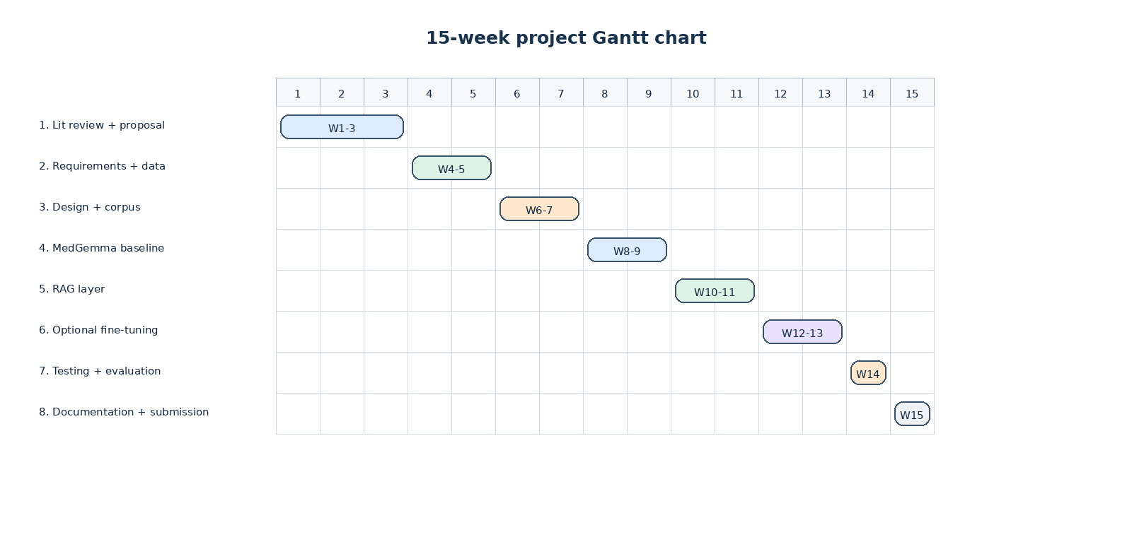
Figure 3.2: Gantt chart of the project plan

Work Breakdown Structure
The work plan is built around the eight phases above. The work breakdown structure (WBS) in Table 3.12 expands each phase into the concrete tasks that the developer and the supervisor track during supervision meetings. The Gantt chart in Figure 3.2 plots the same phases against the 15-week calendar.
WBS code | Task | Phase | Owner
1.1 | Search for and read primary sources on CXR VLMs and RAG in healthcare | 1 | Developer
1.2 | Draft and submit the Project Proposal | 1 | Developer
1.3 | Supervisor sign-off on the proposal | 1 | Supervisor
2.1 | Document analysis of teaching resources and dataset documentation | 2 | Developer
2.2 | Functional and non-functional requirements | 2 | Developer
2.3 | Use case diagram and user stories | 2 | Developer
2.4 | Select the target findings and the dataset subset | 2 | Developer
3.1 | Architectural design (Clean Architecture + hexagonal ports) | 3 | Developer
3.2 | Data flow diagrams (DFDs) | 3 | Developer
3.3 | Interface design (UI mockups and screen flow) | 3 | Developer
3.4 | Curate the educational RAG corpus and the source register | 3 | Developer
4.1 | Implement the backend domain and ports | 4 | Developer
4.2 | Implement the data layer (NIH loader, manifest repo, SQLite) | 4 | Developer
4.3 | Implement the MedGemma runtime (Kaggle notebook + tunnel client) | 4 | Developer
4.4 | Implement the FastAPI routes and the auth layer | 4 | Developer
4.5 | Implement the React frontend (login, case list, case, feedback) | 4 | Developer
5.1 | Implement the IRetriever port and the NullRetriever default | 5 | Developer
5.2 | Implement a corpus-backed retriever and a retrieval-aware prompt | 5 | Developer
5.3 | Surface retrieved sources in the feedback view | 5 | Developer
6.1 | Curate a small labelled set for fine-tuning (skipped if time does not allow) | 6 | Developer
6.2 | Run a small LoRA / PEFT fine-tune pass (skipped if time does not allow) | 6 | Developer
7.1 | Unit tests (domain, application, infrastructure, interfaces) | 7 | Developer
7.2 | Integration tests (auth, case list, attempt, feedback, reviews) | 7 | Developer
7.3 | Run the evaluation harness and produce the Phase 1 report | 7 | Developer
7.4 | Reviewer / educator rubric review of the feedback samples | 7 | Reviewer
8.1 | Finalise the methodology, artefact and conclusion chapters | 8 | Developer
8.2 | Prepare the appendices and the user manual | 8 | Developer
8.3 | Final submission | 8 | Developer
Table 3.12: Work breakdown structure of the project

Risk and Mitigation
The principal operational risks are Kaggle GPU quota, ngrok session lifetime and delayed access to MedGemma. The dry-run analyzer, an idempotent rebuild script and the separation of the model behind IMedGemmaClient mitigate these risks. Legal and data risks are addressed in Table 3.5.

Chapter Summary
This chapter has described the planning, feasibility, requirement-gathering, development, testing and project-management methods used for the artefact. The resulting requirements and methodological decisions provide the basis for the detailed design in Chapter 4.

DESIGN

Chapter Overview
The design phase translates the requirements into the structure of the artefact. The physical design (Section 4.3.4) describes the data flow between the student, the frontend, the backend, the retriever and the model. The architecture design (Section 4.2) describes the layered Clean Architecture that organises the backend code. The interface design (Section 4.3.7) describes the screens and the screen flow that the student and the educator use.

System Architecture Diagram

Architectural Diagram
The backend follows a Clean Architecture in four layers: domain, application, infrastructure and interfaces. The domain holds the entities and the ports; the application layer holds the use cases; infrastructure holds the adapters that implement the ports; and interfaces holds the HTTP surface. Dependencies point inward only, so the domain knows nothing of FastAPI, SQLite, MedGemma or the corpus. Figure 4.1 shows the arrangement.
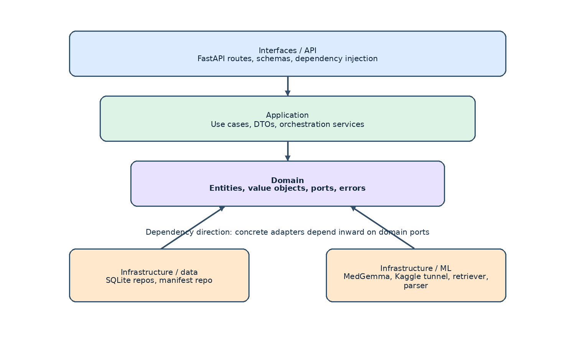
Figure 4.1: High-level system architecture (Clean Architecture and hexagonal ports)

Discussion of Tiers/Components of the Architecture
Dependency inversion means use cases import protocols — ICaseRepository, IMedGemmaClient, IImageAnalyzer, IRetriever and the rest — and never concrete classes, so a single composition root decides which implementation is bound at run time. That is what allows the model and the retriever to be swapped by configuration, which Chapter 6's five arms depend on. Table 4.1 gives the folder structure.
Folder | Contents
backend/src/cxt/domain/ | Entities (Case, User, StudentAttempt, Feedback, Review), value objects (FindingLabel, Confidence, Rationale, Email), ports (ICaseRepository, IMedGemmaClient, IImageAnalyzer, IRetriever, IFeedbackGenerator, IUserRepository, IAttemptRepository, IReviewRepository, IAuthService), errors.
backend/src/cxt/application/ | Use cases (auth, list_cases, submit_attempt, generate_feedback, review_attempt, list_reviews), DTOs, JWT service.
backend/src/cxt/infrastructure/ | Config (Pydantic Settings), data (SQLite repos, manifest repo, NIH loader), auth (argon2 hasher, JWT service), ml (MedGemma analyzer, Kaggle tunnel client, dry-run analyzer, output parser, prompts), retrieval (NullRetriever, corpus-backed retriever), eval (the evaluation harness), logging setup.
backend/src/cxt/interfaces/ | FastAPI app (composition root), routes (auth, cases, attempts, feedback, reviews), schemas, middleware (CORS, request_id), exception handlers.
backend/src/cxt/shared/ | DomainError hierarchy, shared types.
backend/src/cxt/notebooks/ | Prompt-experiments notebook (evaluate_variation, VARIATIONS).
backend/scripts/ | download_nih_subset.py, build_manifest.py, run_eval.py, seed_admin.py, dev.py.
kaggle_runtime/ | medgemma_server.py, prompts/system.txt, prompts/user.txt, README.md.
backend/tests/ | Mirror the source tree; unit, integration, and golden tests.
Table 4.1: Backend folder structure (Clean Architecture)

Detailed Design

Component Diagram
Figure 4.2 shows the component diagram and Figure 4.5 the deployment diagram. The components map one to one onto the layers above: the interface layer exposes the routes, the application layer holds the use cases, and each adapter in the infrastructure layer stands behind exactly one port.
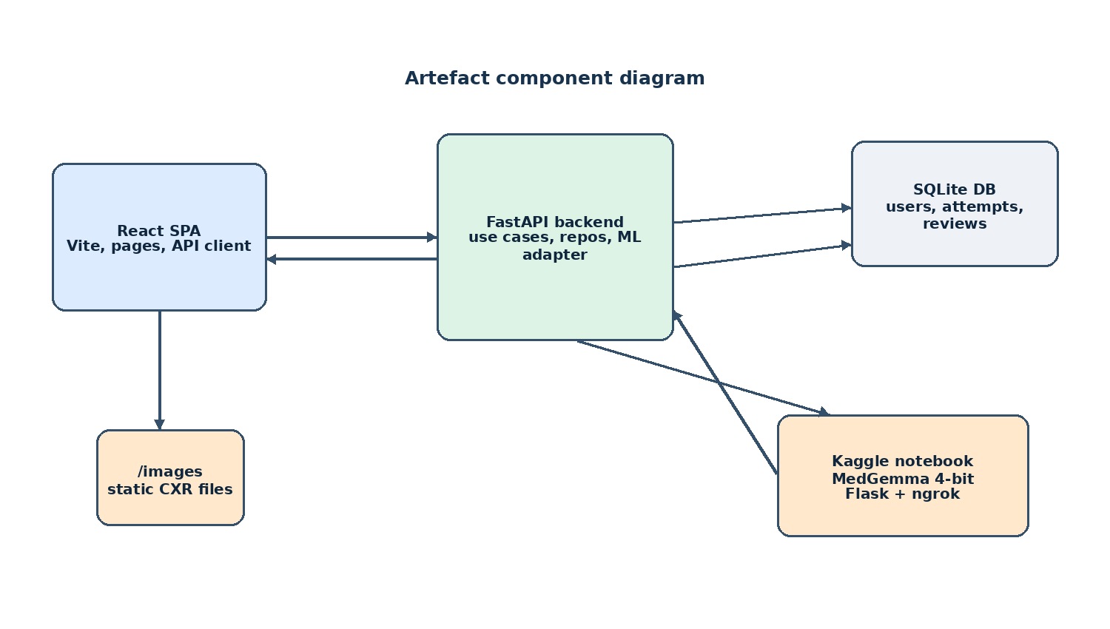
Figure 4.2: Component diagram of the artefact

Sequence Diagram
Figure 4.2a shows the ordered interactions that occur after a student opens a case and submits an interpretation. The backend persists the attempt before invoking the model, retrieves supporting teaching evidence after model analysis, then validates, stores and returns the composed feedback.
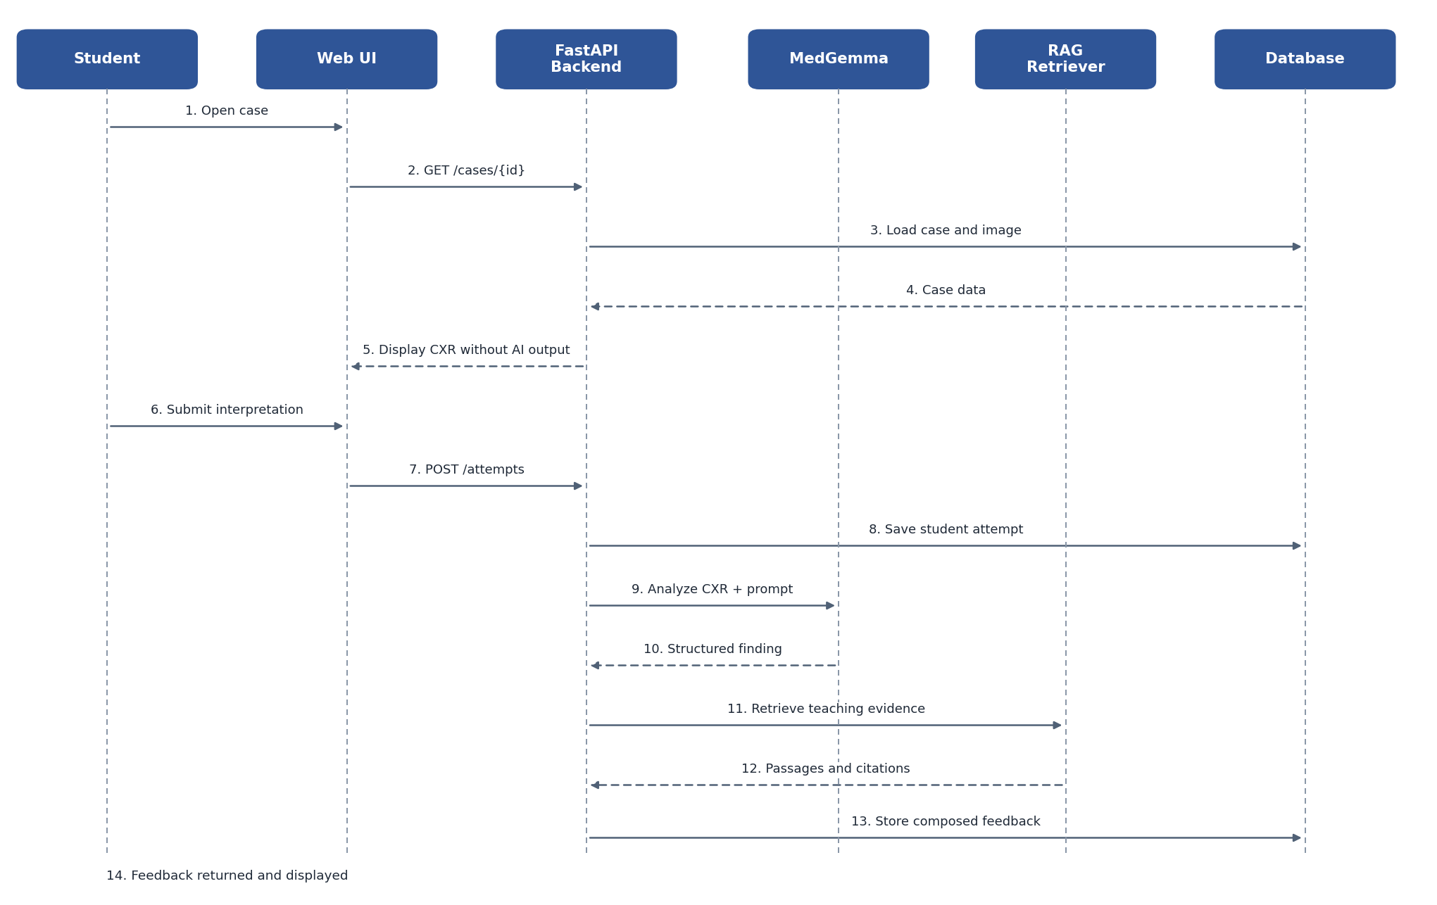
Figure 4.2a: Sequence diagram for student attempt and AI feedback generation

Activity Diagram
Figure 4.2b presents the same workflow as an activity model. It emphasizes validation and exception paths: invalid student input is returned for correction, while invalid AI output is logged and withheld so the student can retry without seeing incomplete feedback.
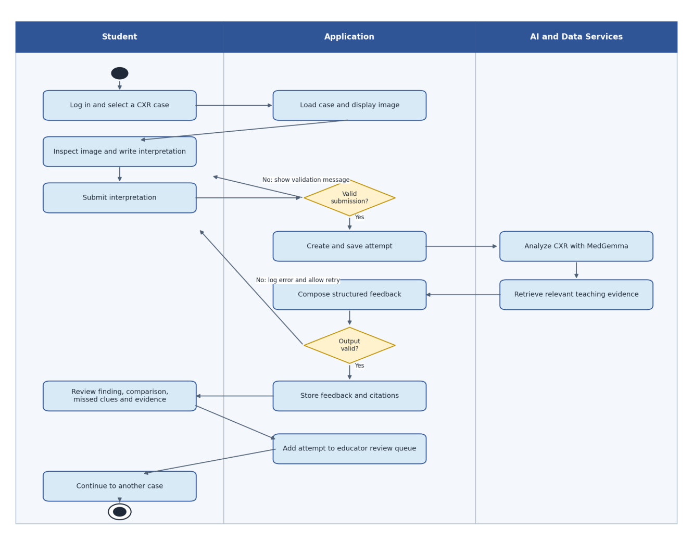
Figure 4.2b: Activity diagram for the student-to-feedback workflow

Physical Design and Data Flow
The physical design is captured in the data flow diagrams: Figure 4.3 is the context-level diagram and Figure 4.4 decomposes the system into its sub-processes, showing where the student's text, the image, the retrieved passages and the generated feedback each flow and where each is stored.
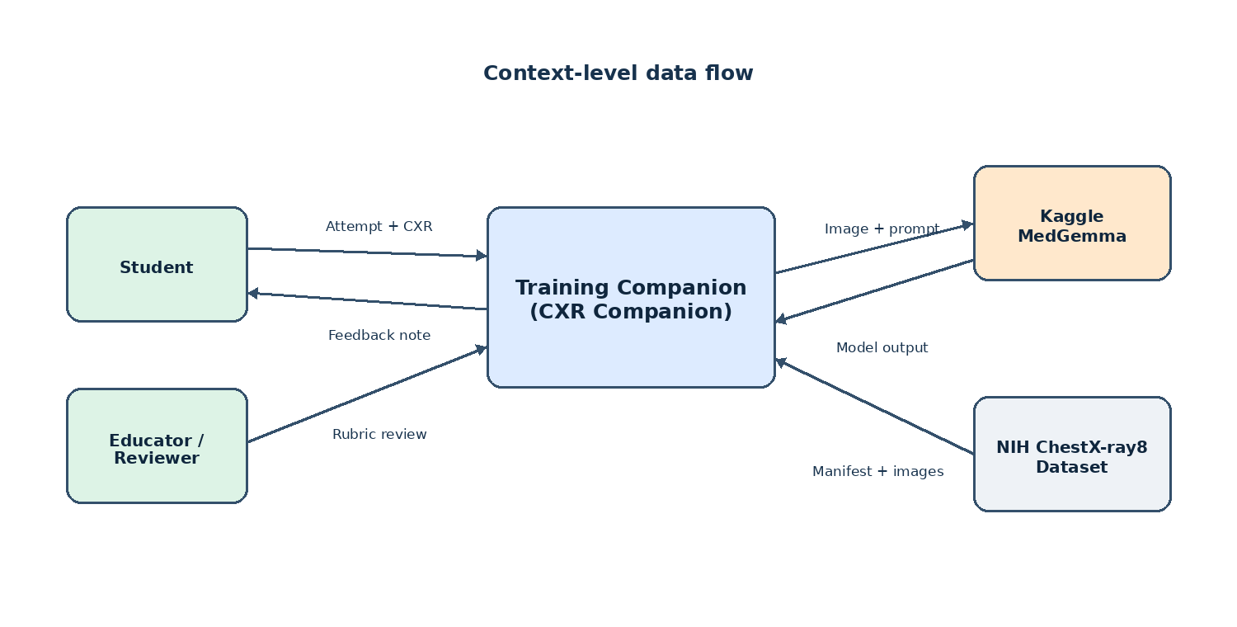
Figure 4.3: Context-level Data Flow Diagram (Level 0)
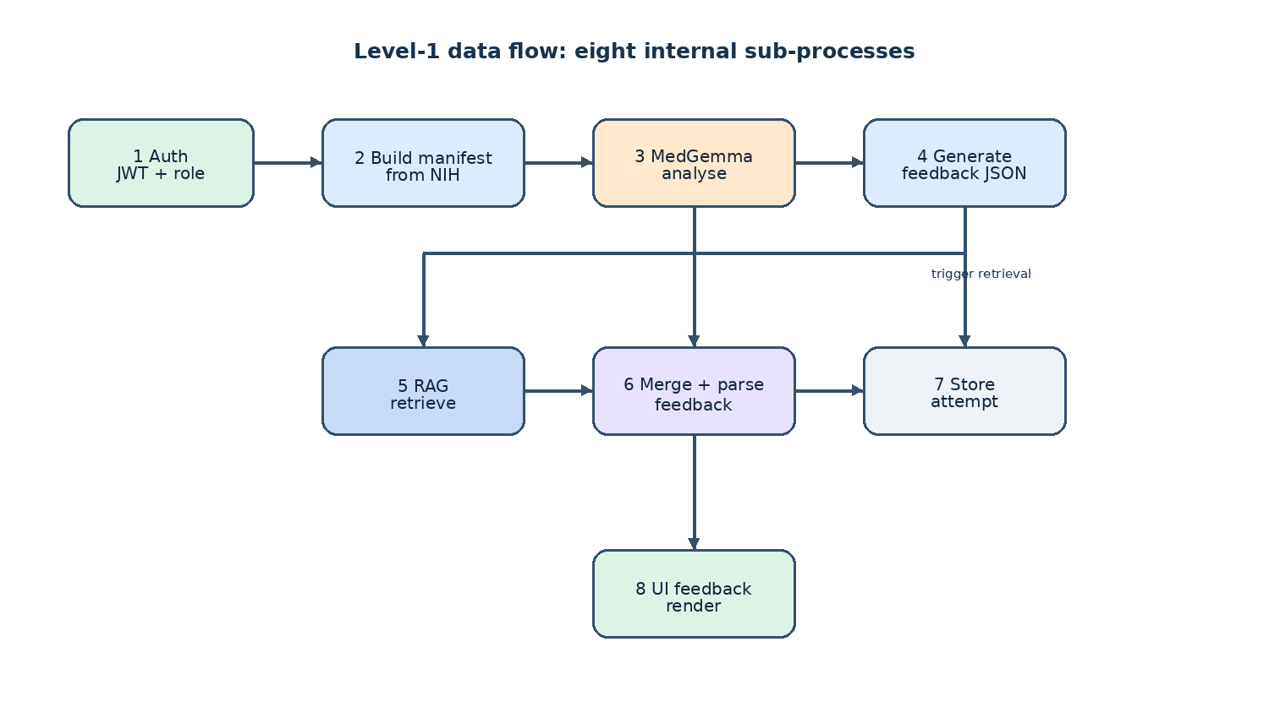
Figure 4.4: Level-1 Data Flow Diagram: sub-processes of the system

Deployment Diagram
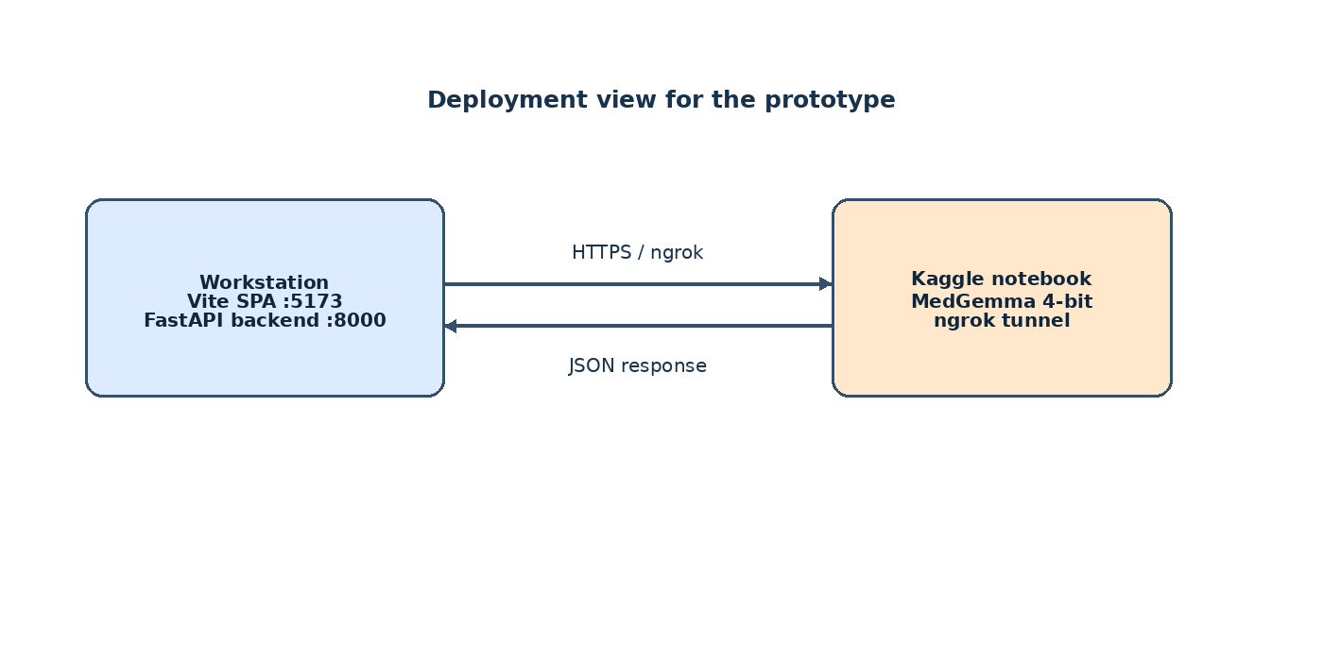
Figure 4.5: Deployment diagram

Interface Design
The interface design covers the student and educator workflows. Figure 4.6 shows the student screen flow and Figure 4.7 the educator flow; Table 4.2 lists the routes.
Route | Page | Purpose
/login | LoginPage | Email + password sign-in
/register | RegisterPage | Self-registration as STUDENT
/cases | CaseListPage | Grid of curated CXR cases with thumbnails and 'Case of {Label}' titles
/cases/{id} | CasePage | CXR viewer + AttemptForm + FeedbackSection after submission
/reviews | ReviewQueuePage | Educator / admin queue of submitted attempts
/reviews/{attemptId} | ReviewPage | Educator / admin rubric scoring of a single attempt
Table 4.2: Frontend route structure
The interface follows a number of consistent design principles:
A persistent educational-use banner is shown on every page ('For educational use only. Not for clinical decision-making, diagnosis, treatment or patient management.').
The student always sees the CXR first and writes their interpretation before any AI output is shown. The submit button is the only way to reveal the feedback.
The feedback view separates the model's primary finding (with a confidence percentage) from the key signs, the comparison with the student's answer, the missed clues and the learning point.
Retrieved sources are listed as a collapsible 'Show evidence' panel so the RAG contribution is visible to the student and to the educator but does not dominate the screen.
The case list shows a 1:1 thumbnail and a demographics subtitle ('56-year-old male - AP view') so the student can scan a case before opening it.
The educator review screen presents a structured rubric: finding recognition, evidence grounding, clarity, learning usefulness, safety. Each criterion is on a 1-5 scale with a free-text comment field.
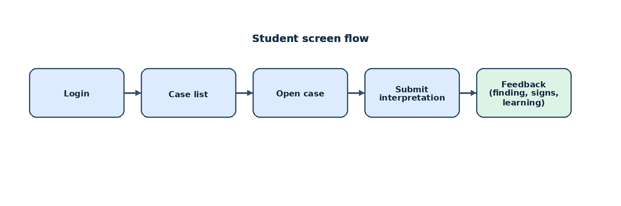
Figure 4.6: Student workflow screen flow (login, case list, case and feedback)
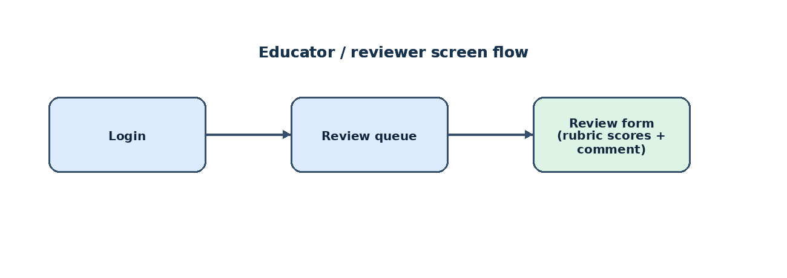
Figure 4.7: Educator workflow screen flow (login, review queue and review form)

Algorithm Design
Equation 4.1 is used in the cardiomegaly prompt template and is reproduced here as the only formal equation in the design chapter.
CTR = max(cardiac width) / max(thoracic width) (Equation 4.1)
where CTR is the cardiothoracic ratio. The conventional screening threshold for cardiomegaly on a true PA film is CTR greater than 0.5 (Zambrano Chaves et al., 2025).

Chapter Summary
The design combines Clean Architecture, explicit ports for model and retrieval services, structured data flows and separate student and educator interfaces. These decisions translate the requirements from Chapter 3 into an implementation-ready system structure.

IMPLEMENTATION

Chapter Overview
This chapter describes how the design in Chapter 4 was built: the technology chosen, the implementation of each functional and non-functional requirement, the retrieval and prompt algorithms that Chapter 4 only sketched, and the user interface. The emphasis is on decisions forced by something measured during development, because those are the ones Chapter 6 has to be read against.

Technology Selection
The stack proposed in Section 3.5.1 was adopted with one revision. The binding constraint was the one in Table 3.3: the project has no budget, so every component had to be free, and the real cost is Kaggle GPU quota rather than money.

Technology Stack
The artefact has three deployable parts. The backend is a Python 3.11+ FastAPI service in the four layers described in Section 4.2. The frontend is a TypeScript single-page application built with React and Vite. The model runtime is a small FastAPI server inside a Kaggle notebook, holding MedGemma in GPU memory and reached over an ngrok HTTPS tunnel. Persistence is one SQLite file, and the cases are a CSV manifest rather than a table because they are read-only reference data built by a script.

Programming Languages
Python was chosen for the backend because the libraries MedGemma is loaded through are Python-first, and because the same language then covers the data scripts, the evaluation harness and the notebook server. The floor is 3.11 in pyproject.toml; development used 3.13.1. TypeScript was chosen for the frontend because the backend returns a structured feedback object with six fields plus a passage list, and a compile-time contract between the two ends turns a whole class of rendering bug into a failed build rather than something the browser discovers.

Development Framework
FastAPI was chosen over Flask and Django. Django was too opinionated for an artefact whose central claim is that the model, the retriever and the dataset are replaceable behind narrow interfaces, since its conventions pull persistence into the domain. Flask was a real alternative, and is what the notebook server uses, but FastAPI's dependency injection gives exactly the composition root the design needs. On the frontend, at six routes, the framework mattered less than the surrounding libraries: TanStack Query for server state, react-hook-form with Zod for the attempt form, react-router for the role-guarded routes, and Tailwind for styling.

Libraries and Toolkits
The backend runtime depends on thirteen third-party packages, all pinned to exact versions and listed in Table 5.1. The Phase 2 retrieval work deliberately added nothing to that list: BM25 is implemented in pure Python and the corpus is read from a prebuilt JSON index, so the YAML parser that builds the index is a development dependency, alongside pytest with pytest-asyncio and pytest-cov, ruff and mypy as the quality gates, and black as the formatter. Frontend dependencies are in Table 5.2.
Package | Version | Role in the artefact
fastapi | 0.115.0 | HTTP framework, dependency injection, OpenAPI schema
uvicorn[standard] | 0.32.0 | ASGI server for the backend
pydantic | 2.9.2 | Request and response schema validation
pydantic-settings | 2.6.0 | Typed configuration loaded from the environment
SQLAlchemy | 2.0.36 | ORM for users, attempts and reviews
alembic | 1.13.3 | Schema migration tooling
PyJWT | 2.9.0 | HS256 access-token issue and verification
argon2-cffi | 23.1.0 | Argon2id password hashing
python-multipart | 0.0.12 | Form parsing support for FastAPI
httpx | 0.27.2 | HTTP client for the Kaggle tunnel
tenacity | 9.0.0 | Exponential-backoff retry around the model call
python-dotenv | 1.0.1 | Loading local configuration from a .env file
Pillow | 10.4.0 | Image handling in the data-curation scripts
Table 5.1: Backend runtime dependencies and their role
Package | Version | Role in the artefact
react, react-dom | 19.2.7 | Component rendering
react-router-dom | 7.18.1 | Client-side routing and route guards
@tanstack/react-query | 5.101.4 | Server-state caching, retries and mutations
react-hook-form | 7.83.0 | Controlled attempt and review forms
zod, @hookform/resolvers | 3.25.76, 3.10.0 | Client-side validation of the free-text answer
vite, @vitejs/plugin-react | 8.1.1, 6.0.3 | Development server and production bundler
tailwindcss, postcss, autoprefixer | 3.4.19, 8.5.23, 10.5.4 | Styling
typescript | 6.0.2 | Static typing and the pre-bundle type check
oxlint | 1.71.0 | Frontend linting
Table 5.2: Frontend dependencies and their role
One deviation from Chapter 3 should be recorded. Section 3.5.1 names React 18; the artefact uses React 19.2.7, because react-router 7 and TanStack Query 5 had both moved to React 19 as their primary target. Nothing in the artefact depends on the difference.

Integrated Development Environments (IDEs)
Development used Visual Studio Code on Windows 11, with Git for version control. The Kaggle notebook editor ran the model runtime, its cells generated from files in the repository so that the code on the GPU is the code under version control.

Summary of Technology Selection
Table 5.3 consolidates the selection and the justification for each category.
Category | Technology selected | Justification
Backend language | Python 3.11+ (3.13.1 used) | Required by the transformers stack; one language for service, scripts and evaluation
Backend framework | FastAPI 0.115 | Dependency injection provides the composition root the architecture requires; free OpenAPI schema
Frontend language | TypeScript 6.0 | Compile-time contract against the structured feedback object
Frontend framework | React 19 with Vite 8 | Small component surface; mature ecosystem for forms, routing and server state
Persistence | SQLite via SQLAlchemy 2 | Zero-configuration single-file database, adequate for a single-user prototype
Case data | CSV manifest + static image mount | Read-only reference data rebuilt by a reproducible script; no migration surface
Model | MedGemma 1.5-4B-IT at bfloat16 | Open medical vision-language model; bfloat16 is the only precision that generates reliably
Model hosting | Kaggle notebook + ngrok tunnel | Free T4 GPU access within a 30-hour weekly quota
Retrieval | Okapi BM25, pure Python | Transparent, defensible ranking with no additional runtime dependency
Quality gates | ruff, mypy --strict, pytest, oxlint | Static and dynamic verification runnable on every change without a GPU
IDE and tooling | Visual Studio Code, Git | Free, cross-platform, integrated Python and TypeScript support
Table 5.3: Summary of technology selection and justification

Implementation of the Artefact
Table 5.6 maps each functional requirement to the module that implements it and the test that establishes it. The subsections that follow expand the five requirements where the implementation was shaped by something discovered during development; the rest are stated completely by the table.
Req. | Implemented by | Mechanism | Evidencing test
FR-1 | ManifestRepository | 300-case CSV manifest, built offline, served via StaticFiles | test_app_routes.py
FR-2 | AttemptForm, SubmitAttemptUseCase | attempt persisted before the model is called; 20-2,000 characters, enforced on both sides | test_attempts_route.py
FR-3 | KaggleTunnelMedGemmaClient, MedGemmaAnalyzer | base64 image over an HTTPS tunnel, retried with backoff | test_medgemma_analyzer.py
FR-4 | BM25Retriever and three siblings | four strategies behind one IRetriever port | test_retrievers.py
FR-5 | OutputParser, PromptBuilder | retrieve-then-generate, JSON repair, ground-truth guard | test_output_parser.py
FR-6 | SourceList, FeedbackSection | passages returned with source, licence and rank | test_submit_attempt_retrieval.py
FR-7 | ReviewAttemptUseCase, EducatorReview | six-criterion rubric, scores 1-5, role re-checked in the use case | test_reviews_route.py
FR-8 | Role enumeration, two FastAPI dependencies | token parsed and role checked at the boundary and again in the use case | test_reviews_route.py
Table 5.6: Functional requirements, the module implementing each, and its test

Implementation of functional requirements

FR-1 — Display a chest X-ray image from a curated public dataset
Cases are not held in the database. A two-stage offline pipeline reads a local copy of NIH ChestX-ray8 with its metadata, records a SHA-256 checksum and the NIH labels for all 4,999 candidate files, then applies the label mapping from Section 3.3 and writes manifest.csv.
The manifest holds exactly 300 cases: fifty each of pneumothorax, pleural effusion, cardiomegaly, consolidation, nodule or mass, and no finding. Splits are assigned by hashing the case identifier against a 70/15/15 ratio, so a rebuild reproduces the same split without storing it, which is why the realised counts are 221, 34 and 45 rather than exactly 210, 45 and 45.
Two properties of this data set limit what Chapter 6 can claim. The fourteen NIH labels contain no fracture class, so although fracture is one of the seven categories the domain recognises, no fracture case exists and the category cannot be evaluated. And the 300 images come from only 86 patients, one of whom contributes 47, so sampling that ignores patient identity draws the same chest repeatedly and reports it as coverage.

FR-2 — Record the student's own interpretation before any AI output
The ordering constraint is the pedagogical core of the artefact, so it is enforced twice. FeedbackSection is not mounted until a submission has returned, so no path through the interface shows model output before the student has committed an answer; and SubmitAttemptUseCase persists the attempt before it calls the analyser, so the student's own words survive a failed model call.

FR-3 — Analyse the image with MedGemma
The model is reached through three classes: KaggleTunnelMedGemmaClient makes the HTTP call, MedGemmaAnalyzer wraps it and treats an empty response as an upstream failure, and LocalImageLoader turns a manifest path into PNG bytes, confining every path it resolves to the configured image directory because a manifest row is data. Images are sent as base64 in the request body rather than as a URL, since the notebook shares no filesystem with the backend; the client also sends an ngrok-skip-browser-warning header, without which ngrok's free tier returns an HTML interstitial instead of JSON.
Transient failures are retried with exponential backoff, up to three attempts, for network errors and 5xx responses only. A 4xx is surfaced at once, since repeating a request the server has already rejected as malformed wastes GPU quota without changing the outcome.
The notebook server loads the checkpoint before it advertises the tunnel, because loading it lazily meant the first submission burned the whole retry budget while the weights were still being read. It then runs a sanity generation against a synthetic image and refuses to report itself healthy unless the model answers, which turns the precision failure described below into an immediate error rather than a silent twenty-five minute one.

FR-4 — Retrieve relevant teaching evidence using RAG
The corpus is a set of Markdown files, and a chunk is an authored section rather than a fixed-size window. There is deliberately no chunking algorithm: a token window adds a parameter that would have to be defended and would cut sentences in the middle of describing a sign. Each file carries YAML front matter recording source, URL, licence, licence URL and retrieval date, and each section its own identifier, findings, aspect and common confusions.
The build script validates every one of those fields and writes an index with a SHA-256 of each source. Validation is enforcement, not advice: a chunk whose licence is not on the allowlist fails the build, because the repository is public and an unlicensed extract is published the moment it is committed. The allowlist takes the permissive and share-alike Creative Commons variants and excludes anything NoDerivatives, since a chunked adaptation is exactly what that forbids.
The submitted corpus is version c1.30: 30 chunks across four files, mean length 540 characters against a ceiling of 700. Coverage by finding is consolidation 8, nodule or mass 8, pleural effusion 8, cardiomegaly 7, pneumothorax 6 and no finding 5; by aspect, 10 radiographic sign, 9 differential, 8 pitfall, 2 technique and 1 management. Twenty-four chunks carry a verified further-reading link. The 700-character ceiling is not arbitrary: three passages, a 2,000-character answer and the template must fit the notebook's 8,000-character user turn.
Four retrieval strategies are implemented behind the single IRetriever port and selected by configuration, which is what makes the five-arm comparison in Chapter 6 an experiment rather than four separate builds. They are summarised in Table 5.4.
Setting | Class | Behaviour and purpose
null | NullRetriever | Returns nothing. Reproduces Phase 1 behaviour exactly and serves as the control arm. This is the default, so an existing deployment is unchanged until retrieval is asked for.
oracle | CategoryRetriever | Filters the corpus to the case's confirmed category, then ranks within it. An upper bound answering “does supplying correct evidence help?”, not a retrieval result.
bm25 | BM25Retriever | Unfiltered BM25 over the whole corpus, keyed on the student's free text. The only arm that yields a non-circular relevance figure.
misconception | MisconceptionRetriever | BM25 with a multiplicative boost toward chunks tagged as addressing the confusion the student appears to have made.
Table 5.4: The four retrieval strategies implemented behind the IRetriever port

FR-5 — Generate the structured feedback note
The most consequential decision in Phase 2 was to move retrieval so that it runs before the model is called rather than after. In the Phase 1 build, passages were attached to the finished feedback, which grounded nothing: a grounding metric over such an attachment measures only whether prose written in ignorance happens to agree with a document it never saw. Retrieval now produces the passages, they are rendered into the user turn, and the model writes with them in front of it.
Two failure modes degrade rather than error. A retrieval failure yields an empty passage list, so a broken index drops the system to Phase 1 behaviour instead of failing the submission; and a failure to persist the feedback is logged but the feedback is still returned, because a student should not lose an answer to a database problem.

FR-6 — Display retrieved source citations alongside the feedback
No relevance score is shown to the student. A percentage beside a citation implies a reliability the number does not carry, because a BM25 rank is not a probability that the passage is right about this patient, and in a tool meant to help students calibrate their own judgement an authoritative-looking figure beside a keyword match is worse than none. The scores are still recorded on the feedback object for the evaluation to read.
Each passage renders as a collapsible card inside the application rather than a link out to a corpus file, collapsed by default, since three 700-character chunks expanded would bury the teaching point they support. Cards are keyed on the chunk identifier rather than the source, because several chunks share one document.

FR-7 — Educator review queue and rubric-based reviews
The review feature is three use cases behind four routes, backed by SqliteReviewRepository. Each use case re-checks the caller's role internally rather than trusting the route guard, so the rule holds for any delivery mechanism, and EducatorReview validates that every score is an integer from one to five and that every criterion named is one it recognises.
One defect in this feature was found during implementation review and corrected. The domain recognises six criteria — finding recognition, retrieval relevance, evidence grounding, clarity, usefulness for learning, and safety and trustworthiness — but the review form submitted a different six, left behind when the rubric was revised on the backend without updating the frontend. Because the entity rejects unrecognised criteria, every review sent through the interface failed with HTTP 422, so FR-7 could not be completed by the only route an educator has. The form now sends the domain's list, shown in Figure 5.7, and a test fails if the two ever drift apart again.

FR-8 — Enforce role separation

Implementation of non-functional requirements
Table 5.5 maps each non-functional requirement from Table 3.8 to the mechanism that satisfies it and the module in which that mechanism lives. The subsections that follow expand the three requirements where the implementation is not self-evident.
ID | Quality | Mechanism in the artefact
NFR-1 | Usability | Student-facing labels, a collapsed evidence panel, and no numeric score beside a citation; bounded free-text input with inline validation
NFR-2 | Reliability | Model finding, supplied passages and student comparison are separate fields; the ground-truth guard overrides a mismatched category and records that it did so
NFR-3 | Security | Argon2id hashing, HS256 tokens with issuer and audience verification, role guards in both the route and the use case, path confinement on image loading, CORS allowlist
NFR-4 | Traceability | Prompt version with content fingerprint, model identifier, repair attempts, retrieval mode, top-k, corpus version and abstention flag recorded on every feedback row
NFR-5 | Performance | Corpus and BM25 index built once per process; bounded model timeouts with backoff; a degraded health status when the tunnel is unreachable
NFR-6 | Privacy | De-identified public images only; the ngrok URL is redacted in logs; the persisted provenance allowlist excludes the raw model response
NFR-7 | Maintainability | Nine ports in the domain, concrete adapters bound only in the composition root, ruff and mypy --strict over 95 files
Table 5.5: Implementation of the non-functional requirements

NFR-3 — Security
Passwords are hashed with Argon2id, and verification catches the library's mismatch and invalid-hash errors and returns false rather than propagating, so a malformed stored hash cannot be told apart from a wrong password. Access tokens are HS256 JWTs with subject, role, issue time, expiry, issuer and audience claims and an eight-hour lifetime; the service refuses to start with a secret under sixteen characters, and verification checks issuer and audience rather than only the signature.
Two further controls address risks specific to this kind of application. The image loader confines every resolved path to the configured directory, so a crafted manifest row cannot name an arbitrary file, and the tunnel URL is treated as a bearer capability, since anyone holding it can send work to the GPU, and is redacted before it reaches any log line. These map onto the injection and sensitive-data-exposure categories of the OWASP Top 10 (OWASP Foundation, 2021) and the excessive-agency and sensitive-information categories of its large-language-model counterpart (OWASP Foundation, 2025), within the governance framing of the National Institute of Standards and Technology (2023).

NFR-4 — Traceability
Every feedback row records what produced it. The prompt version is stored as its label joined to a twelve-character SHA-256 fingerprint of the prompt text, so an edit that forgets to increment the version still changes the fingerprint and two runs on different wording cannot be compared by mistake. Alongside it sit the model identifier, the repair-attempt count, the retrieval mode, the corpus version, an explicit abstention flag, the ranked chunk identifiers with their scores, and any citation labels that were stripped. Abstention is stored rather than inferred from an empty list, because it is a deliberate outcome of the score floor and not a missing value.

NFR-7 — Maintainability
The dependency rule is enforced structurally: the domain declares nine ports as protocols and imports nothing from infrastructure, use cases accept those protocols rather than concrete classes, and one composition root binds the implementations. Expensive objects are cached per process on hashable primitives rather than on the settings object, which Pydantic renders unhashable by defining equality without a hash; the original version cached on the object itself and every live submission failed inside the decorator.
The composition root also decides how to fail. If the corpus cannot be loaded, the retriever factory returns the null retriever, degrading to Phase 1 behaviour rather than taking the API down; if the tunnel runtime is selected with no URL configured, the analyser factory raises an error naming the missing setting. Ruff and mypy in strict mode both run clean across 95 source files.

Algorithm Implementation
Section 4.4 gave the cardiothoracic ratio as the design chapter's only formal algorithm. Implementation added three further pieces of logic that are algorithmic rather than structural, documented here because Chapter 6 measures them.

Prompt construction and the token budget
Prompts are not literal strings in code. The system and user templates are text files under one directory per version, so the notebook and the backend share byte-identical text, and substitution uses Template rather than format strings, because the student's text is untrusted and a single brace in an answer would raise before the model was ever called.
The most important thing the prompt does is supply the confirmed finding rather than ask for it. That was a contract change forced by measurement: across six prompt strategies, finding recognition sat between 16.7 and 25.0 per cent against a chance floor of 16.7 for a seven-way choice. The artefact was redefined from a system that diagnoses to a tutor that marks a student's interpretation against a finding it already knows.
Two later revisions show the same discipline. One version told the model to report any second finding it saw; on one case it recovered a true additional finding, and on another it invented a right-sided pleural effusion on a film with a confirmed pneumothorax, which is the physical opposite, so that version was reverted. A later one removed an instruction to credit the student for any finding they had identified, because it had told a student who wrote that the lungs looked mostly clear that they had correctly identified a pleural effusion.
The notebook server caps the system turn at 4,000 characters and the user turn at 8,000. Filling in the clinical context, which had always rendered as “no clinical context provided” despite the manifest holding age, sex and view, pushed the worst-case system prompt to 4,123, so the JSON schema block was moved into the user turn, where the evidence block already lives.
Passages are rendered into the user turn as opaque labels, [S1] to [S3], carrying no source identity. Naming the source would invite the model to weigh the authority of a publication against what it can see in the image, which is the reasoning the artefact is trying not to encourage.

Ranking and score normalisation
Retrieval uses Okapi BM25 with the conventional parameters k1 = 1.2 and b = 0.75, implemented in pure Python over an inverted index built once per process. Tokenisation is a lowercase alphanumeric split with no stemming and no stop-word list, because both are tunable knobs that would have to be defended, and because digits are meaningful in this corpus: 0.50, the cardiothoracic threshold, is a real term. The inverse document frequency uses the smoothed form given in Equation 5.1.
IDF(t) = log(1 + (N − df(t) + 0.5) / (df(t) + 0.5)) (Equation 5.1)
where N is the number of chunks and df(t) the number containing term t. The smoothed form was chosen over the textbook Robertson–Sparck Jones expression, which goes negative for any term appearing in more than half the corpus. With thirty chunks all concerning the chest, “lung” and “chest” cross that threshold, and a negative contribution would penalise a chunk for containing a word the student used.
Raw BM25 scores are unbounded and corpus-dependent, so they are mapped into the unit interval by the saturating transform in Equation 5.2, with k = 4.
score = bm25 / (bm25 + k) (Equation 5.2)
The normalisation is absolute rather than relative to the top hit. Dividing by the top score would make the best result 1.0 however little BM25 liked it, and would leave no floor below which the system could decide it has nothing useful. The transform is monotone, so it changes the scale and not the ordering, and ties break on corpus insertion order, because otherwise the evaluation would be measuring dictionary iteration order and reporting it as retrieval quality.
Abstention follows from the floor. Results are returned in descending order and the first below 0.25 — a raw BM25 of about 1.3, or one mid-frequency term match — ends the list. If nothing clears it, no passages are supplied, the prompt says so, and no evidence panel is rendered. Showing a barely relevant passage for the sake of completeness teaches a student to discount citations, which is the opposite of the intended effect.

Misconception detection and the negation guard
The misconception arm boosts chunks tagged as addressing the confusion a student appears to have made. Identifying that confusion is itself a classification problem, and a learned classifier was rejected: the model managed 16.7 to 25.0 per cent on an easier seven-way task, so asking it to label the student's error would put something close to a coin flip inside the retrieval signal. The implementation is an explicitly labelled lexical proxy over an auditable list of surface forms, with three known failure cases documented beside it.
Negation is treated as the central problem rather than an edge case: a student who writes that there is no pneumothorax has correctly excluded it, and a naive matcher records them as having claimed it. The scanner covers nineteen forward cues and, critically, fourteen postposed ones, since “pneumothorax is ruled out” means the same as “no pneumothorax” and a forward-only scanner reads the student as asserting exactly what they excluded. A negation runs for forty characters or until a contrast word or sentence boundary, and negated spans are blanked with spaces rather than deleted, so offsets stay valid and adjacent clauses cannot fuse into a phrase neither contained. The boost is multiplicative and applied before normalisation, so a chunk with no lexical match still scores zero: the boost reorders, it never conjures relevance from nothing.

Output parsing, the ground-truth guard and citation enforcement
The parser is permissive on input and strict on output. The model's private reasoning is stripped before any JSON is sought, because MedGemma wraps it in reserved tokens and it is prose full of quoted category names that would otherwise be mistaken for the answer. Repairs are attempted cheapest first: raw text, smart-quote normalisation, extraction between the first and last brace, trailing-comma removal, and finally a routine that tracks string and escape state, cuts back to the last complete member and appends the missing closing brackets. Category names are canonicalised through an alias table, and if every repair fails the output is re-prompted once with its own parse error attached before the submission is failed.
One invariant was moved out of the prompt and into the parser. Differential confidences must not exceed the primary finding's, and three successive prompt versions moved the violation rate from three cases in six to two and then to four, with no monotone improvement. That is a wording lottery rather than a fix, so each differential is now clamped in code.
Two guards run after parsing. The ground-truth guard compares the model's category against the case's confirmed categories and, on a mismatch, substitutes the case's truth while recording both the model's original answer and the fact of the override. It accepts any confirmed category rather than only the primary one, because on a case labelled with both cardiomegaly and effusion, answering cardiomegaly is following the prompt. The citation guard scans every prose field for bracketed source labels and removes any pointing outside the passages actually supplied; it removes rather than repoints, because redirecting a fabricated citation at a real passage would assert that the passage says something nobody checked. Stripped labels are recorded, and that record is what the evaluation reads.

User Interface Implementation
The interface is a single-page application of six routes, listed in Table 4.2. Server state is held by TanStack Query with one retry, a thirty-second freshness window and refetch-on-focus disabled, so returning to the tab does not silently re-issue a model call. All network access goes through one request helper, which injects the bearer token and converts error responses into a typed client error and a toast; a 401 clears the token and redirects to login.
The educational-use banner specified in Section 4.3.6 is rendered by the application shell, so it is present on every route, including login and registration, and a user meets it before they meet any model output. The screens are described below, with screenshots of the running application in Figures 5.1 to 5.7.
The case list shows the curated cases as a grid of thumbnails, each titled with its confirmed label and subtitled with the demographics line.
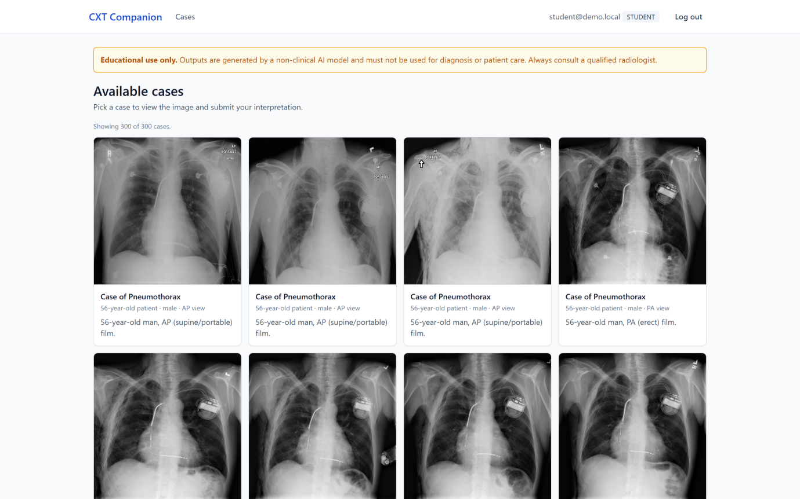
Figure 5.1: Case list showing curated cases with thumbnails and demographics
The case page puts the radiograph beside the attempt form, with a viewer that zooms between one half and four times and pans.
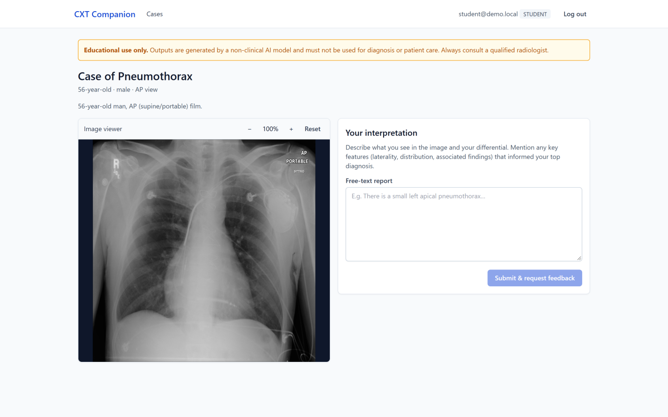
Figure 5.2: Case page with the radiograph viewer and the free-text attempt form
The attempt form disables submission until the answer is between 20 and 2,000 characters, and shows the reason inline rather than only on submit.
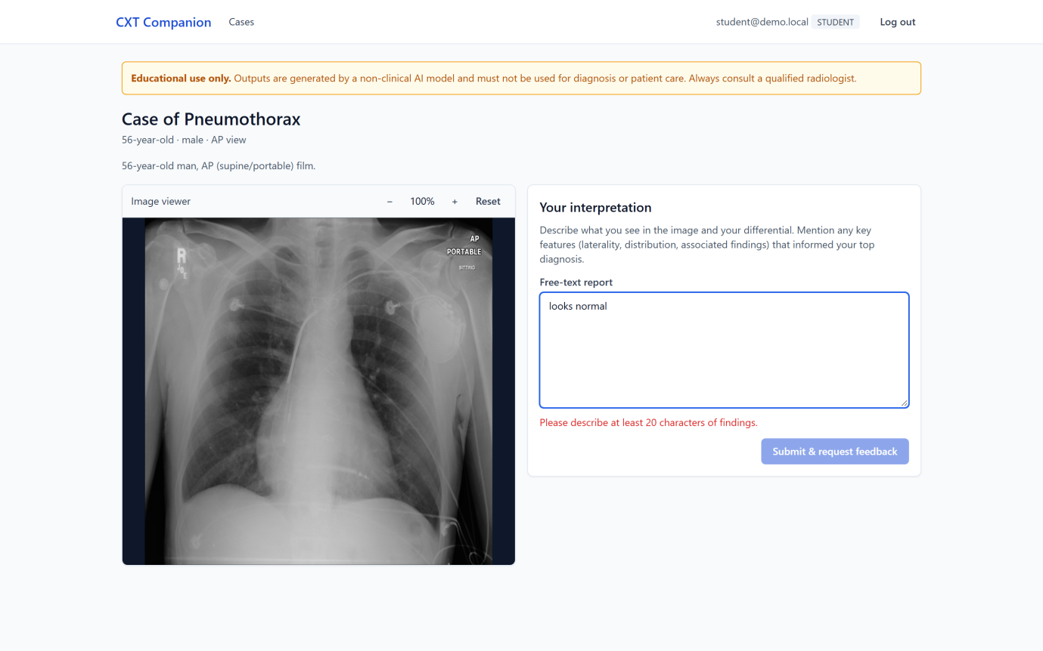
Figure 5.3: Attempt form with inline validation of the free-text answer
The feedback view separates the primary finding and its confidence from the key signs, the observations, the comparison with what the student wrote and the teaching point.
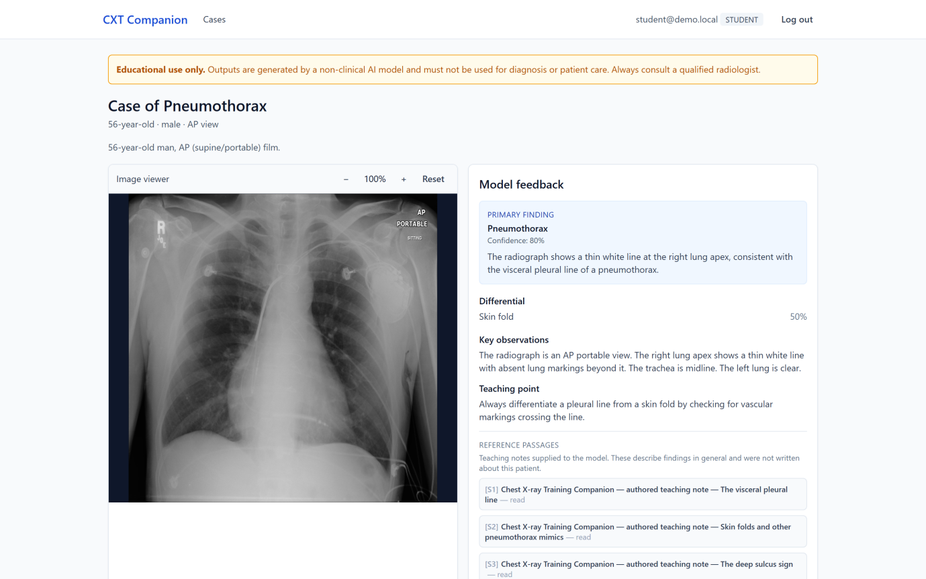
Figure 5.4: Structured feedback note returned after submission
Retrieved passages sit beneath the feedback as collapsed cards, each with its licence line and, where one exists, a verified further-reading link.
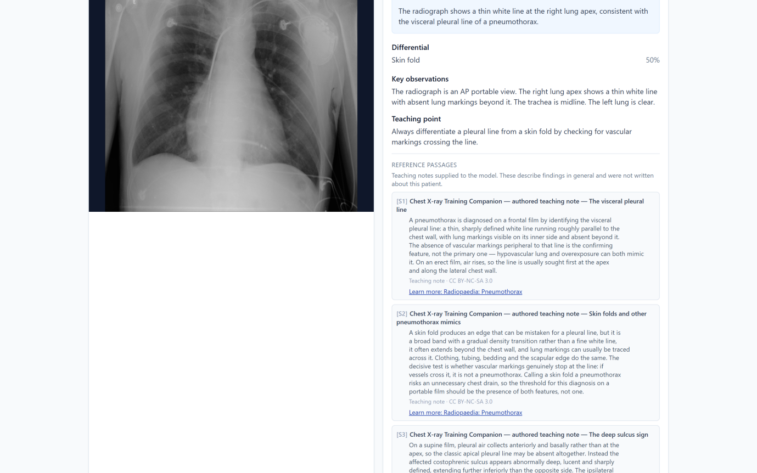
Figure 5.5: Evidence panel showing retrieved teaching passages
The educator screens are reachable only with the educator or administrator role, guarded on the route as well as on the server.
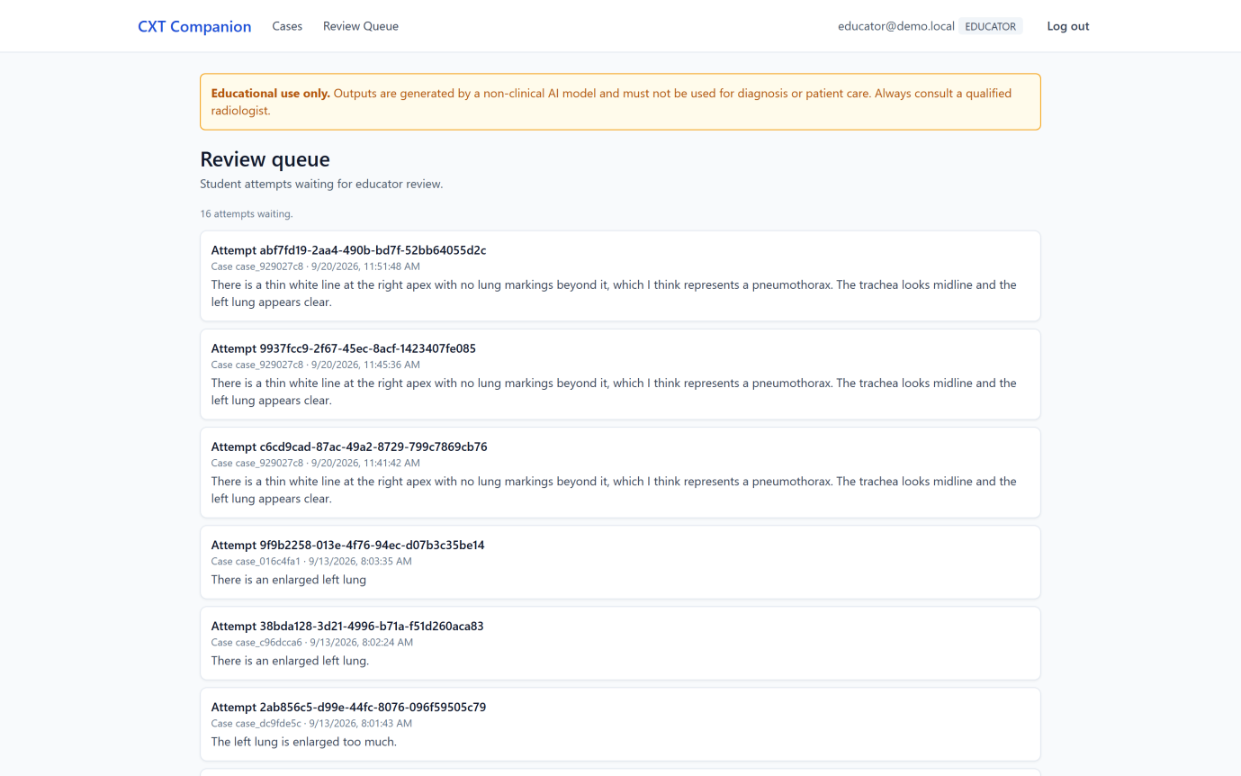
Figure 5.6: Educator review queue
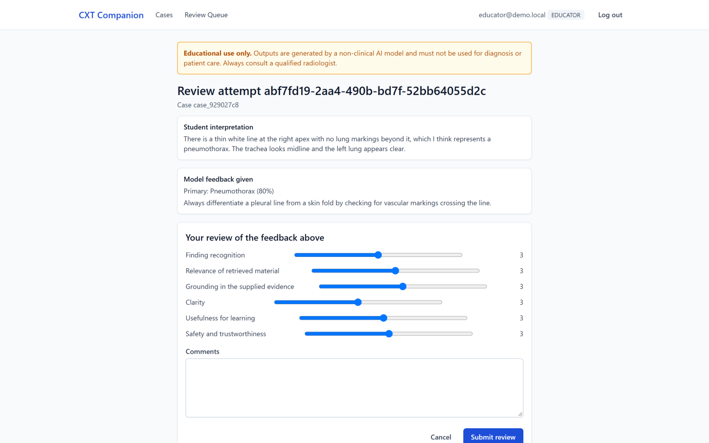
Figure 5.7: Educator rubric form, scoring the six criteria the domain accepts

Chapter Summary
The artefact was built as specified in Chapter 4, with the model and the retriever behind ports so both can be swapped by configuration. Several decisions in this chapter were forced by measurement rather than chosen: supplying the confirmed finding instead of asking for it, retrieving before generating rather than after, and showing a rank instead of a score. Chapter 6 reports what those decisions produced.

TESTING

Chapter Overview
This chapter reports how the system was tested and what the testing found: the automated suite, the two rounds of model evaluation on the held-out test split, the functional test cases, and the non-functional checks. Results are reported as they came out, including the ones that were worse than hoped, because a testing chapter that only reports successes is not evidence of anything.

Objectives and Goals of Testing
Testing had to establish four things: that a student can open a case, submit an interpretation and get a structured note back; that the model's output parses into the Feedback entity often enough to be usable; that retrieval supplies passages about the finding rather than passages that merely share words with the student's answer; and that the feedback stays tied to what the system was given.
Two things were deliberately not tested. Clinical correctness needs a qualified radiologist and none was available, and learning gain needs a study with real students over time, which Section 1.7 puts out of scope.

Testing Criteria
The pass thresholds come from the rubric agreed in Section 3.4.3. Structure validity had to reach 95 per cent, since a note that does not parse is shown to nobody, and every functional requirement had to be exercised by a passing automated test. Precision@3 was given no fixed threshold, because no comparable published figure exists for a corpus of this kind, so it is reported against the control arm. Confabulation had to be lower with retrieval than without it, which is the claim retrieval has to earn.
Finding recognition was deliberately given no threshold. Phase 1 put the model close to chance on the seven-way task, and the architecture was changed so that the system is told the confirmed finding rather than having to guess it, so scoring an ability it no longer needs would measure the wrong thing. NFR-1 and NFR-5 are stated qualitatively in Table 3.8 as “clear” and “understandable”, so Section 6.7 assesses them by inspection and says so rather than inventing a number.

Model / System Testing
Phase 1 evaluated MedGemma on its own, before retrieval existed. Six prompt versions were run against the held-out test split to find out whether the model could identify the finding from the image. Table 6.1 gives the results.
Run | Prompt | n | Structure validity | Finding recognition | Median latency
e1.0 (fp16) | e1.0 | 30 | 0.0% | 0.0% | 48.9 s
e1.0 (bf16) | e1.0 | 30 | 100.0% | 23.3% | 28.5 s
e2.0 | e2.0 | 30 | 96.7% | 23.3% | 28.5 s
e3.0 | e3.0 | 12 | 100.0% | 16.7% | 30.4 s
e3.1 | e3.1 | 12 | 91.7% | 16.7% | 31.9 s
e4.0 | e4.0 | 30 | 80.0% | 16.7% | 46.2 s
e5.0 | e5.0 | 30 | 86.7% | 23.3% / 40.0% | 46.2 s
Table 6.1: Phase 1 prompt experiments on the held-out test split
Three things stand out. The fp16 run produced nothing usable: structure validity was 0%, and the raw output showed the model emitting repeated tokens rather than JSON, so all later runs used bf16. Second, elaborating the prompt made things worse — e4.0 and e5.0 are the longest prompts and have the lowest structure validity and the slowest responses. Third, and most importantly, finding recognition never moved out of the 16.7% to 23.3% band across six prompting strategies, against a seven-way chance floor of 14.3%.
The e5.0 run reports recognition twice because it was scored two ways: strictly against the single mapped NIH category (23.3%), and leniently, crediting any category the case's NIH labels support (40.0%). The gap is a reminder that the labels are NLP-mined from radiology reports and are noisy, which Section 7.4 returns to.
This is what forced the change of architecture described in Section 4.4: instead of asking the model to classify the image, the system supplies the confirmed finding and asks it to teach against it. Everything from Phase 2 onwards tests that design.

Evaluation Metrics
Phase 2 reports six measures, and two pairs of them only mean anything together. Citation rate is the share of notes citing at least one passage, citation validity the share of citations pointing at a passage actually supplied; a model citing nothing scores 100 per cent validity having done nothing, so neither is reported alone. Lexical overlap is likewise reported beside a shuffled control, because any two texts about chest radiographs share words and only the gap is evidence.
Precision@3 is the share of retrieved passages tagged with a finding the case confirms, excluding passages whose aspect is management. Confabulation is the share of notes naming a finding that neither the case nor any supplied passage supports. Both are lexical proxies, and Section 6.4.3 tests the first against an independent labelling.

Retrieval and Feedback Evaluation
The Phase 2 evaluation compares five arms over the same 30 (case, student answer) pairs, all run in one notebook session so that model drift cannot explain any difference between them. The pairs are drawn five from each of the six findings and spread across all six student archetypes. Table 6.2 gives the results.
Arm | Retrieval | Cite rate | P@3 | Coverage | Overlap (null) | Confab.
p2.4 | none | 0% | n/a | 0 | 0.000 (0.000) | 62%
p3.0-empty | none (control) | 0% | n/a | 0 | 0.000 (0.000) | 60%
p3.0-oracle | confirmed category | 0% | n/a | 29 | 0.088 (0.045) | 20%
p3.0-bm25 | free text | 0% | 52% | 29 | 0.087 (0.049) | 23%
p3.0-misconception | free text + boost | 0% | 53% | 28 | 0.085 (0.049) | 27%
Table 6.2: The five-arm Phase 2 comparison, 30 samples per arm
The headline result is the confabulation column. With no passages supplied, about six notes in ten name a finding that nothing supports; with passages supplied, that falls to between two and three in ten. The effect is clearest on the five cases whose ground truth is no finding: both no-retrieval arms invented a finding on all five, while the retrieval arms did so at most twice. Given nothing to work from, the model will not accept that a chest film is normal.
The overlap figures point the same way. The retrieval arms sit around 0.087 against a shuffled null of about 0.049, so the feedback shares roughly twice as many content words with the passages it was given as with passages it was not. The gap is small but consistent across all three retrieval arms.
Citation rate, however, is 0% in every arm. Across 150 generations the model never once wrote an [S1]-style citation, even though the user turn asks it to. Section 7.3 discusses the likely cause: the system prompt's absolute instruction that a passage is never evidence about this patient pulls against the user turn's request to cite one. This is a negative result and is reported as one.
Precision@3 is 52% for BM25 and 53% for the misconception variant, so the boost makes almost no difference at this corpus size. The aggregate hides a more interesting pattern, given in Table 6.3.
Student archetype | P@3 (BM25) | Reading
correct | 80% | student names the finding, so the query is rich
wrong_laterality | 80% | names the finding, wrong side
right_wrong_reason | 64% | names the finding, poor justification
confidently_wrong | 33% | names a different finding
vague | 27% | says very little
missed | 25% | does not mention the finding at all
Table 6.3: Precision@3 by student archetype, BM25 arm
Retrieval works well when the student already names the finding and collapses when they do not. That is what a retriever keyed on the student's free text has to do, and it is an uncomfortable result, because the students who most need the right passage are the ones who wrote least about the finding. The same pattern shows by category: precision is 73% on cardiomegaly but 7% on no finding, where there is nothing for the student to describe and so nothing to match on.

Retrieval Relevance Agreement
Precision@3 is computed from tag overlap, which is cheap and obviously incomplete: a passage tagged with the right finding might still not help this student. All 150 retrieved pairs from the BM25 arm were therefore labelled independently as relevant, not relevant, or unsure. Table 6.4 compares the two.
 | Judge: relevant | Judge: not relevant
Proxy: relevant | 56 | 22
Proxy: not relevant | 3 | 47
Table 6.4: The tag-overlap proxy against independent labelling, 128 decisive pairs
Raw agreement is 80% over the 128 pairs where the labeller was not unsure, and Cohen's kappa is 0.62, conventionally described as substantial. Kappa is reported alongside raw agreement because raw agreement flatters a metric when one label dominates.
The disagreements are lopsided in a useful way: 22 pairs the proxy called relevant and the labeller did not, against only 3 the other way — the failure the proxy was predicted to have. Agreement was highest on radiographic signs (87 per cent) and lowest on technique (67 per cent), which fits, since a general note on portable films is topically relevant to almost everything and pedagogically relevant to very little.
One limitation has to be stated plainly. The labels were produced by a language model acting as an independent judge, not by a radiology educator, and are stored separately from the empty labelling sheet so the two cannot be confused. The figures show the proxy agreeing with a second automatic judgement, not with expert human judgement; Section 7.4 records this.

Functional Testing
Each functional requirement from Table 3.9 is checked by at least one automated test. Table 6.5 gives one test case per requirement, naming the test that establishes the result; no case is marked as passing on a manual check that was not actually run.
ID | Req. | Expected result | Evidencing test | Result
TC01 | FR-1 | A curated case and its image are served to a signed-in student | test_app_routes.py | Pass
TC02 | FR-2 | An answer under 20 characters is rejected before any model call | test_attempts_route.py | Pass
TC03 | FR-3 | The image is analysed and a raw model response returned | test_medgemma_analyzer.py | Pass
TC04 | FR-4 | Retrieval returns passages tagged for the confirmed finding | test_retrievers.py | Pass
TC05 | FR-5 | Model output parses into a valid Feedback entity, repairing malformed JSON | test_output_parser.py | Pass
TC06 | FR-6 | Supplied passages are returned to the client with their source and licence | test_submit_attempt_retrieval.py | Pass
TC07 | FR-7 | An educator submits rubric scores and they are persisted | test_reviews_route.py | Pass
TC08 | FR-8 | A student is refused access to the educator review queue | test_reviews_route.py | Pass
Table 6.5: Functional test cases, one per functional requirement
TC07 is worth a note. The review form originally submitted six criteria the domain does not accept, so every review sent through the interface was rejected with HTTP 422 and FR-7 could not be completed by the only route an educator has. It was found during implementation review and corrected, and a test now fails if the two lists drift apart again. Figure 5.7 shows the corrected form.

Module and Integration Testing
The automated suite collects 591 tests, of which 589 pass and 2 are skipped. The two skipped are the live-tunnel smoke tests, which run only when a tunnel URL is configured because they call a real GPU service. Table 6.6 shows the distribution.
Layer | Tests | What is covered
Domain | 57 | entities, value objects, validation rules
Application | 59 | use cases, including retrieval-aware submission
Infrastructure: evaluation | 134 | metric definitions and the eval harness
Infrastructure: retrieval | 104 | BM25, the four retrievers, corpus loading
Infrastructure: ML | 93 | prompt building, output parsing, tunnel client
Infrastructure: data | 75 | manifest repository, SQLite repositories
Infrastructure: auth | 16 | hashing, token issue and verification
Interfaces | 37 | API routes, role guards
Integration and golden | 8 | cross-layer paths and frozen output checks
Table 6.6: Automated tests by layer
The largest block sits on the evaluation code rather than the application. That is deliberate: the metrics are what the report makes claims from, and a metric that computes something plausible but different from what it claims is the worst failure available, because it produces a number that looks reasonable and is wrong. Two such bugs were found and fixed during this project, and the tests that would have caught them are now in the suite.

Accuracy / Performance Comparison
Table 6.2 answers AQ4. On this evidence, grounding the model in retrieved teaching material improves the feedback, and the improvement holds across all six findings rather than one.
The qualification is that the oracle arm, given passages chosen using the answer key, does no better than BM25. If retrieval quality were the binding constraint the oracle should be clearly ahead; that it is not suggests the corpus is the limit, since at 30 chunks BM25 and the oracle often supply much the same material, and 29 of the 30 chunks were retrieved at least once.
Latency is not comparable with the Phase 1 figures and is not a regression. The p3.0 prompt is longer and passages lengthen it further, from about 4,300 characters to about 6,900, so median response time rose from roughly 28 seconds to roughly 30 — a small cost for the grounding improvement, though both are far too slow for comfortable interactive use.

Non-Functional Testing
Static analysis is clean. Ruff reports no violations and mypy in strict mode reports no issues across 95 source files, which is checked on every run of the project's lint command.
Security testing for NFR-3 covers what the project controls. Passwords are hashed rather than stored, tokens are verified on every protected route, and role separation is enforced by a dependency the educator routes declare, with TC08 confirming a student is refused the review queue. The known weakness is the tunnel URL, which acts as a bearer capability for the model service and is kept out of version control.
Traceability for NFR-4 was checked by inspecting stored feedback: each record carries the prompt version, the retrieval mode, the corpus version and the identifiers of the passages supplied, so any note shown to a student can be traced to the configuration that produced it.
NFR-1 and NFR-5 were assessed by inspecting the interface against the six principles quoted in Section 4.3.6. The feedback note is broken into labelled sections rather than returned as a wall of prose, the educational-use warning appears on every screen, and passages are shown with their source and licence and a note saying they describe findings in general and were not written about this patient. Figures 5.4 and 5.5 show both. This is inspection, not measurement.

Chapter Summary
Testing established that the application works end to end, that every functional requirement is exercised by a passing automated test, and that grounding the model in retrieved passages substantially reduces the rate at which it asserts findings nothing supports. It also established three things that did not work: the model cannot identify findings from the image at better than close to chance, it never cites the passages it is given, and retrieval degrades badly for exactly the students whose answers say least. Chapter 7 assesses the project against the objectives set out in Chapter 1.

CONCLUSION

Chapter Overview
This chapter assesses how far the aim in Section 1.4 and the six objectives in Section 1.6 were achieved. It then covers the problems met during the project, the limitations of the finished work, the deviations from the proposal, directions for future work, and a short closing statement.

Achievements of Research Aims & Objectives

Achievement of the Research Aim
The aim was to design, implement and evaluate a student-in-the-loop chest X-ray training companion using MedGemma and Retrieval-Augmented Generation to give structured, evidence-grounded feedback on a small set of common findings. A working prototype exists: a student records their own reading of a curated radiograph, MedGemma writes a structured feedback note against passages retrieved before generation, and those passages are shown to the student beside the feedback. The model, the retriever and the dataset sit behind narrow ports, which was the design claim the project set out to test, and the five configurable retrieval arms are the practical demonstration of it.
The evaluation was carried out and is reported in Chapter 6. Retrieval reduces the rate at which the model asserts findings nothing supports from about 61 per cent to between 20 and 27 per cent, and lexical overlap with the supplied passages runs at roughly twice its shuffled null. The aim is therefore achieved, with the qualification that the evidence is 30 samples per arm on a 30-chunk corpus, and that the system never once cited a passage it was given.

Achievement of Objectives
Table 7.1 summarises the position against each objective; the paragraphs that follow expand the two that are not fully met.
Objective | Status | Evidence
O1 — Review literature and systems, identify limitations for educational use | Achieved | Chapter 2; the gap analysis in Section 2.3 and the comparison in Table 2.1
O2 — Select findings and gather public image data and labels | Achieved | 300-case balanced NIH subset, six categories, reproducible build with per-file checksums
O3 — Gather and analyse functional and non-functional requirements | Achieved | Tables 3.7 and 3.8; six use-case narratives; the traceability mapping in Table 3.9
O4 — Design the architecture, data flow and educational RAG corpus | Achieved, corpus below target | Chapter 4; corpus version c1.30 of 30 licence-validated chunks against a 50–80 target
O5 — Implement the student-attempt-then-AI-feedback workflow | Achieved | Chapter 5; 589 passing automated tests; ruff and mypy --strict clean across 95 files
O6 — Test and evaluate, comparing configurations, and document the findings | Achieved | Phase 1 experiments e1.0–e5.0 and the five-arm Phase 2 comparison reported in Chapter 6; the fine-tuned arm was not attempted
Table 7.1: Achievement of the research objectives
Objective O4 is met in structure but short in volume. The corpus is built, validated and licence-enforced, and it covers all five positive findings with at least six chunks each, which is above the minimum needed for precision at three to be meaningful. It contains thirty chunks where the plan targeted between fifty and eighty. The shortfall has a specific cause, described in Section 7.3.
Objective O6 is achieved. Five prompt sets were evaluated on the held-out split in Phase 1, and the five-arm Phase 2 comparison was run within a single notebook session so that model drift cannot explain the differences between the arms. Both are reported in Chapter 6. The third configuration named in AQ4, a fine-tuned MedGemma with retrieval, was not attempted; it was scoped as conditional from the outset and is recorded as a deviation below.

Problems and Challenges Faced
The defining problem was that the model could not do the task the project was originally designed around. Finding recognition sat between 16.7 and 25.0 per cent across six prompt sets, against a chance floor of 16.7 per cent for a seven-way choice. The label audits made the failure concrete rather than merely numerical: on several runs the model collapsed onto one answer, predicting pleural effusion on nine of twelve cases in one configuration and cardiomegaly on ten of eleven in another. Elaborating the prompt did not help; the longest prompt sets dropped structure validity from 100 to 80 per cent and pushed 95th-percentile latency from 33 seconds to 275 while leaving accuracy in the same band.
The response was to change what the system is rather than keep tuning the prompt. From p2.0 onward the confirmed finding is supplied and the model's job is to mark the student's interpretation against it. That is a smaller claim than the proposal made, and a better fit for a teaching tool: marking a known case is a defensible role for a model that cannot reliably diagnose. It also made the Phase 2 retrieval work more valuable, because the question became whether evidence improves the marking rather than whether it improves a diagnosis.
A second problem cost a disproportionate amount of time and is worth recording as a methodological lesson. An early run at float16 returned HTTP 200 for all thirty cases and produced zero parseable outputs. Gemma-family models carry activations that overflow the float16 exponent range, so the model emitted an immediate end-of-sequence token and the server reported success with an empty body, with nothing in the logs to say otherwise. The fix was bfloat16, but the durable change was a sanity generation at load time, so the server refuses to report itself healthy unless the model actually produces text. That turns a twenty-five minute silent failure into an immediate one.
Third, the corpus was harder to source than expected. The plan was to extract teaching text from the WHO Manual of Diagnostic Imaging. The licence had to be verified rather than assumed, because the publication predates the organisation's open-access policy, and radiographs in such publications are often third-party and would need separate permission in any case. The corpus submitted is therefore author-written teaching notes aligned to the source material rather than extracts from it, offered under a share-alike licence, with the build script enforcing a licence allowlist so an unlicensed extract cannot reach a public repository by accident.
Fourth, the operational risks anticipated in Section 3.6.2 all materialised. The Kaggle free tier allows thirty GPU hours a week, which binds when one five-arm evaluation takes over an hour and has to run in a single session. The tunnel URL changes on every notebook restart and is itself a bearer capability, so it had to be kept out of logs and out of version control. The mitigations planned in Chapter 3 worked: almost all development and the entire test suite run without touching a GPU.

Limitations of the Research
The limitations below constrain what the artefact and its evaluation can be taken to show. They are stated as properties of the work rather than as apologies for it.
Corpus size and provenance. The retrieval corpus contains thirty chunks. With a corpus this small the same few passages can serve many cases, which flatters coverage-insensitive metrics; corpus coverage is reported for exactly this reason. The chunks are also author-written teaching notes rather than extracts from an established textbook, so they carry the author's understanding rather than an independent authority.
Patient concentration. The 300 images come from 86 patients, one of whom contributes 47. Any result computed over a sample that ignores patient identity risks reporting repeated exposure to one chest as coverage across cases. The evaluation harness deduplicates by patient for this reason, but the underlying pool remains narrow.
Label noise. The NIH labels are mined from radiology reports by natural language processing and are known to be noisy. They are treated throughout as a directional signal rather than a clinical reference, and no claim in this report should be read as a clinical accuracy figure.
An untestable category. The fourteen NIH labels contain no fracture class, so one of the seven categories the domain model recognises has no cases and cannot be evaluated at all.
Lexical proxies. Misconception detection is alias matching with a negation guard, not a classifier, and confabulation is detected as a finding named in the feedback that neither the case nor any supplied passage supports. The first identifies which category a student named, not what they misunderstood; the second detects a named finding, not whether the clinical claim about it is false. Both are labelled as proxies in the code and are reported as proxies here.
How the relevance labels were made. The 150 pairs that validate the automatic relevance proxy were labelled by a language model acting as an independent judge, not by a radiology educator. The 80 per cent agreement and kappa of 0.62 in Section 6.4.3 therefore show that the proxy agrees with a second automatic judgement. Agreement with expert human judgement is unmeasured.
No frontend tests. The frontend has no test runner. Linting and the TypeScript compiler are its only automated gates, so every claim about interface behaviour in this report rests on manual observation.
Sample size. Each Phase 2 arm reports 30 samples drawn from 29 cases, which is enough to show a difference of the size observed between retrieval and no retrieval but not enough to separate the three retrieval arms from one another. The differences among them are inside the noise this sample can resolve, and are not claimed as findings.
A sampling defect, found late. The first two evaluation runs capped the sample without balancing it, and because the manifest is ordered by category the cap took five pneumothorax cases and paired each with six student archetypes. Every figure those runs produced described one category while appearing to describe the system. The sampler now interleaves categories and the reported run covers 29 cases across all six, but the episode is recorded because it is the kind of fault that produces confident, well-formatted, wrong numbers.
Unquantified requirements. Two non-functional requirements, usability and performance, are stated qualitatively in Table 3.8 with no numeric threshold, so testing can describe what the system does but cannot declare a pass against a criterion that was never quantified.

Deviations [If Any]
Three deviations from the proposal are recorded. The most significant is the change in the model's role, from proposing a diagnosis to marking a student's interpretation against a supplied finding, for the reasons given in Section 7.3. That was a change of contract rather than of scope, and it is reflected in the prompt versions from p2.0 onward.
The second is that the fine-tuned configuration named as AQ4's third arm was not attempted. It was scoped conditionally in the proposal, appearing in the work breakdown structure as two tasks to be skipped if time did not allow, and the abstract already treats fine-tuning as future work. That time went into the retrieval layer and its evaluation instead, which is the more substantive contribution.
The third is the corpus sourcing change described in Section 7.3, and a minor dependency revision from React 18 to React 19 recorded in Section 5.2.4.

Future Enhancements
Five directions follow from the limitations above.
Corpus expansion. Grow the corpus to the fifty to eighty chunks originally targeted, drawing on licence-cleared published sources rather than author-written notes, and re-run the coverage and precision measurements to see whether the small-corpus degeneracy the metrics were designed to expose actually appears.
Fine-tuning. Attempt the third arm of AQ4 with a small parameter-efficient fine-tune on the underperforming categories, particularly consolidation, which no prompt configuration recognised correctly on any case. Calibration metrics become meaningful at that point in a way they are not for a prompted model.
A second dataset. Swap the dataset to MIMIC-CXR, which the port-based architecture was designed to accommodate with a new loader and no domain change, and report per-dataset results. MIMIC's free-text reports would also permit a richer ground truth than a single mined label.
Human relevance labelling. Have the relevance pairs labelled by two or more radiology educators and report inter-rater agreement, so the automatic proxy is validated against expert consensus rather than against a second automatic judgement.
Frontend verification. Add a frontend test runner and component tests for the feedback and evidence panels, so interface behaviour is verified rather than observed.

Concluding Remarks
The project set out to test whether a medical vision-language model and retrieval could be combined into something useful for a student learning to read chest radiographs. The answer it reached is narrower and more interesting than the one it expected. The model could not reliably say what was on the film, and no amount of prompt engineering moved it meaningfully above chance. Given the finding, though, it can write a structured, readable response to what a student wrote, and it can be made to do so against evidence it was handed: supplying passages cut the rate at which it asserted unsupported findings by roughly two thirds. Reaching that conclusion meant building the measurement first and letting it overrule the original design.
What the artefact demonstrates is not that this model can teach radiology. It is that a system of this kind can be built so that its claims are checkable: every piece of feedback records the prompt that produced it, the passages it was given, and whether the system overrode its answer. For an educational tool in a clinical domain that auditability is the property that matters most, and it is the one this project would carry forward.

References
All in-text citations in this report follow the Harvard referencing style. The reference list is ordered alphabetically by the first author's surname.
Abo El-Enen, M., Saad, S. and Nazmy, T. (2025) 'A survey on retrieval-augmentation generation (RAG) models for healthcare applications', Neural Computing and Applications. Available at: https://doi.org/10.1007/s00521-025-11666-9 (Accessed: 9 June 2026).
Amugongo, L.M., Mascheroni, P., Brooks, S., Doering, S. and Seidel, J. (2025) 'Retrieval augmented generation for large language models in healthcare: A systematic review', PLOS Digital Health, 4(6), e0000877. Available at: https://doi.org/10.1371/journal.pdig.0000877 (Accessed: 27 May 2026).
Chen, Z. et al. (2024) 'A vision-language foundation model to enhance efficiency of chest X-ray interpretation', arXiv:2401.12208. Available at: https://doi.org/10.48550/arXiv.2401.12208 (Accessed: 18 June 2026).
Collaco, B.G. et al. (2026) 'Integrating fine-tuning and retrieval-augmented generation for healthcare AI systems: A scoping review', Bioengineering, 13(2), 225. Available at: https://doi.org/10.3390/bioengineering13020225 (Accessed: 2 June 2026).
European Parliament and Council of the European Union (2016) 'Regulation (EU) 2016/679: General Data Protection Regulation'. Available at: https://eur-lex.europa.eu/eli/reg/2016/679/oj (Accessed: 25 May 2026).
Gosai, A. et al. (2025) 'Beyond diagnosis: Evaluating multimodal LLMs for pathology localization in chest radiographs', arXiv:2509.18015. Available at: https://arxiv.org/abs/2509.18015 (Accessed: 13 June 2026).
Google Developers (2026) MedGemma | Health AI Developer Foundations. Available at: https://developers.google.com/health-ai-developer-foundations/medgemma (Accessed: 4 June 2026).
Johnson, A.E.W. et al. (2019) 'MIMIC-CXR, a de-identified publicly available database of chest radiographs with free-text reports', Scientific Data, 6, 317. Available at: https://doi.org/10.1038/s41597-019-0322-0 (Accessed: 5 June 2026).
Karunaratne, D. (2023) 'The growing problem of radiologist shortage in Sri Lanka', Korean Journal of Radiology, 24(10), pp. 941-943. doi: 10.3348/kjr.2023.0791. Available at: https://pmc.ncbi.nlm.nih.gov/articles/PMC10550747/ (Accessed: 29 May 2026).
Lee, S., Youn, J., Kim, H., Kim, M. and Yoon, S.H. (2025) 'CXR-LLaVA: a multimodal large language model for interpreting chest X-ray images', European Radiology, 35(7), pp. 4374-4386. Available at: https://doi.org/10.1007/s00330-024-11339-6 (Accessed: 20 June 2026).
Li, C. et al. (2023) 'LLaVA-Med: Training a large language-and-vision assistant for biomedicine in one day', Advances in Neural Information Processing Systems 36. Available at: https://proceedings.neurips.cc/paper_files/paper/2023/hash/5abcdf8ecdcacba028c6662789194572-Abstract-Datasets_and_Benchmarks.html (Accessed: 31 May 2026).
Lin, Q. et al. (2025) 'Toward clinically explainable AI for medical diagnosis: A foundation model with human-compatible reasoning via reinforcement learning', arXiv:2509.03906. Available at: https://arxiv.org/abs/2509.03906 (Accessed: 16 June 2026).
Liu, S., McCoy, A.B. and Wright, A. (2025) 'Improving large language model applications in biomedicine with retrieval-augmented generation: A systematic review, meta-analysis, and clinical development guidelines', Journal of the American Medical Informatics Association, 32(4), pp. 605-615. Available at: https://doi.org/10.1093/jamia/ocaf008 (Accessed: 7 June 2026).
Lou, J., Yang, Y., Yu, Z., Fu, Z., Han, W., Huang, Q. and Yu, J. (2025) 'CXRAgent: Director-orchestrated multi-stage reasoning for chest X-ray interpretation', arXiv:2510.21324. Available at: https://arxiv.org/abs/2510.21324 (Accessed: 26 May 2026).
Mugambiwa, T. and Ndlovu, B. (2026) 'Multi-agent retrieval augmented generation for clinical decision support: A systematic review and integrative conceptual framework', Journal of Applied Informatics and Computing, 10(1), pp. 171-183. Available at: https://www.semanticscholar.org/paper/Multi-Agent-Retrieval-Augmented-Generation-for-A-Mugambiwa-Ndlovu/eeab620e9d8c8d0c4215b2d39bcced9fc4d9440c (Accessed: 11 June 2026).
National Institute of Standards and Technology (2023) 'Artificial Intelligence Risk Management Framework (AI RMF 1.0)'. Available at: https://doi.org/10.6028/NIST.AI.100-1 (Accessed: 3 June 2026).
OWASP Foundation (2021) 'OWASP Top 10: The ten most critical web application security risks'. Available at: https://owasp.org/Top10/2021/ (Accessed: 19 June 2026).
OWASP Foundation (2025) 'OWASP Top 10 for Large Language Model Applications'. Available at: https://owasp.org/www-project-top-10-for-large-language-model-applications/ (Accessed: 28 May 2026).
Pal, A. et al. (2025) 'ReXVQA: A large-scale visual question answering benchmark for generalist chest X-ray understanding', arXiv:2506.04353. Available at: https://arxiv.org/abs/2506.04353 (Accessed: 14 June 2026).
Pambudi, S. and Menolascina, F. (2025) 'Bridging clinical narratives and ACR Appropriateness Guidelines: A multi-agent RAG system for medical imaging decisions', arXiv:2510.04969. Available at: https://arxiv.org/abs/2510.04969 (Accessed: 1 June 2026).
Papageorgiou, P.S. et al. (2025) 'The role of large language models in improving diagnostic-related groups assignment and clinical decision support in healthcare systems: An example from radiology and nuclear medicine', Applied Sciences, 15(16), 9005. Available at: https://doi.org/10.3390/app15169005 (Accessed: 10 June 2026).
Parliament of Sri Lanka (2022) 'Personal Data Protection Act, No. 9 of 2022'. Available at: https://parliament.lk/uploads/acts/gbills/english/6242.pdf (Accessed: 6 June 2026).
Sellergren, A. et al. (2025) 'MedGemma Technical Report', arXiv:2507.05201. Available at: https://arxiv.org/abs/2507.05201 (Accessed: 17 June 2026).
Wang, X. et al. (2017) 'ChestX-ray8: Hospital-scale chest X-ray database and benchmarks on weakly-supervised classification and localization of common thorax diseases', Proceedings of the IEEE Conference on Computer Vision and Pattern Recognition (CVPR), pp. 2097-2106. Available at: https://doi.org/10.1109/CVPR.2017.369 (Accessed: 30 May 2026).
World Health Organization (2021) 'Ethics and governance of artificial intelligence for health: WHO guidance'. Geneva: World Health Organization. Available at: https://www.who.int/publications/i/item/9789240029200 (Accessed: 15 June 2026).
Zambrano Chaves, J.M. et al. (2025) 'A clinically accessible small multimodal radiology model and evaluation metric for chest X-ray findings', Nature Communications, 16, 3108. Available at: https://doi.org/10.1038/s41467-025-58344-x (Accessed: 4 June 2026).

Appendices
This appendix records the technical configuration of the artefact as submitted, so that a reader can reproduce the environment in which the results reported in Chapter 6 were obtained. Every value below is taken from the source as built.

Appendix B — Technical Configuration Summary

B.1 Model and inference configuration
Parameter | Value | Note
Model | google/medgemma-1.5-4b-it | Gated on Hugging Face; access applied for at project start
Precision | bfloat16 | float16 produces NaN activations and empty output; selectable but warned against
Device mapping | auto | Required in every precision branch; without it weights remain on CPU
max_new_tokens | 1536 (ceiling 2048) | The model reasons for roughly 750 tokens before emitting JSON; 512 truncated mid-thought
Generation timeout | 300 s (ceiling 600 s) | 1500 tokens at bfloat16 on a pre-Ampere card exceeds one minute
Warm-up timeout | 600 s (ceiling 1800 s) | Loading a 4-billion-parameter checkpoint takes minutes
Client retries | 3 | Exponential backoff 1–8 s; 5xx and network errors only, never 4xx
Parse repair attempts | 1 | One corrective re-prompt carrying the model's own parse error
Maximum image size | 8 MiB | Images are transmitted base64-encoded in the request body
Host | Kaggle notebook, T4 GPU | Free tier, 30 GPU hours per week
Transport | FastAPI server behind an ngrok HTTPS tunnel | Tunnel URL is a bearer capability and is redacted in logs
Server version | 0.4.0 | Reported by /healthz so a stale notebook copy is visible
Table B.1: MedGemma model and inference configuration

B.2 Prompt configuration
Parameter | Value | Note
Production prompt version | p3.0 | Evidence block and JSON schema in the user turn
Baseline prompt version | p2.4 | Frozen Phase 1 prompt, retained as an evaluation arm
Version identifier format | <version>+<12-char SHA-256> | Fingerprint of the prompt text; an unversioned edit still changes it
System turn limit | 4000 characters | Enforced by the notebook server; worst rendered p2.4 prompt is 3982
User turn limit | 8000 characters | Must hold three passages, a 2000-character answer and the template
Clinical context cap | 48 characters | Holds the system-turn budget once the context field is populated
Passage labels | [S1], [S2], [S3] | Opaque and positional; source identity is deliberately withheld from the model
Substitution mechanism | string.Template.safe_substitute | Student free text is untrusted; a literal brace must not raise
Evaluation prompt sets | e1.0 – e5.0 | Phase 1 classification harness, frozen
Table B.2: Prompt configuration and token budget

B.3 Retrieval configuration
Parameter | Value | Note
Ranking function | Okapi BM25, pure Python | No additional runtime dependency
k1 | 1.2 | Term-frequency saturation
b | 0.75 | Length normalisation
Inverse document frequency | log(1 + (N − df + 0.5)/(df + 0.5)) | Smoothed form; the unsmoothed expression goes negative on common terms
Score normalisation | bm25 / (bm25 + 4.0) | Absolute and saturating, not top-1; monotone, so ordering is preserved
Top k | 3 | Configurable 1–10
Score floor | 0.25 | Approximately raw BM25 1.3; below it the system abstains and supplies nothing
Misconception boost | 1.5× | Applied to raw score before normalisation, so it reorders but never conjures relevance
Negation window | 40 characters | Terminated early by a contrast word or sentence boundary
Negation cues | 19 forward, 14 postposed | Postposed cues are required: “ruled out” follows the finding it negates
Tokenisation | lowercase [a-z0-9]+ | No stemming, no stop-word list; digits retained (0.50 is a corpus term)
Tie-break | corpus insertion order | Deterministic, so the evaluation does not measure dictionary iteration order
Runtimes | null | oracle | bm25 | misconception | Default null, reproducing Phase 1 exactly
Table B.3: Retrieval and ranking configuration

B.4 Corpus configuration
Parameter | Value
Corpus version | c1.30.ae7502d34265 (chunk count and content hash)
Chunks | 30, across 4 Markdown source files
Chunk definition | one authored section; no chunking algorithm, no fixed window
Maximum chunk length | 700 characters (mean as built: 540)
Coverage by finding | consolidation 8, nodule or mass 8, pleural effusion 8, cardiomegaly 7, pneumothorax 6, no finding 5
Coverage by aspect | radiographic sign 10, differential 9, pitfall 8, technique 2, management 1
Minimum chunks per finding | 3, below which precision at three is not meaningful
Licence | CC BY-NC-SA 3.0 on all chunks; allowlist enforced by the build, not warned about
Excluded licences | any NoDerivatives variant, since a chunked adaptation is what it forbids
Further-reading links | 24 of 30 chunks carry a verified curated URL
Provenance | per-file SHA-256 recorded in data/corpus/index.json
Table B.4: Retrieval corpus configuration

B.5 Data set configuration
Parameter | Value
Source | NIH ChestX-ray8 (NIHCC), Wang et al. (2017)
Candidate pool | 4,999 files, each checksummed in data/raw/PROVENANCE.json
Curated set | 300 cases: 50 each of six categories
Categories | pneumothorax, pleural effusion, cardiomegaly, consolidation, nodule or mass, no finding
Absent category | fracture — not among the 14 NIH labels, so no case exists
Distinct patients | 86, one contributing 47 images
Multi-label share | approximately 43 per cent of the curated set
Split rule | SHA-256 of the case id bucketed against 70/15/15, applied per case
Realised splits | train 221, validation 34, test 45
Manifest columns | case_id, image_index, image_path, finding, label_source, split, nih_labels, patient_age, patient_sex, view_position
Evaluation sampling | stratified by category, then deduplicated by patient
Student answer fixtures | 36 hand-authored answers: 6 categories × 6 error archetypes
Error archetypes | correct, missed, wrong laterality, right answer for the wrong reason, confidently wrong, vague
Table B.5: Data set and evaluation sampling configuration

B.6 Application configuration
Parameter | Value
Password hashing | Argon2id (argon2-cffi defaults)
Token algorithm | HS256, with issuer and audience verified
Token lifetime | 8 hours
Minimum signing secret | 16 characters, enforced at construction
Roles | STUDENT, EDUCATOR, ADMIN
Free-text bounds | 20–2000 characters, enforced independently on both ends
Database | SQLite; tables users, attempts, reviews
Rubric criteria (domain) | finding recognition, retrieval relevance, evidence grounding, clarity, usefulness for learning, safety and trustworthiness; 1–5 each
Static gates | ruff (E, F, I, N, W, UP, B, SIM, RUF; line length 100) and mypy --strict over 95 files
Automated tests | 591 collected, 589 passing, 2 skipped without a tunnel URL
Table B.6: Application and security configuration

